DETECTING CROP PATHOGENS WITH CONVOLUTIONAL NEURAL NETWORKS

## A PROJECT REPORT

***Submitted by***

# LITIKA G [211421104144]

# HARSHITHA L [211421104095]

# DHARSHANA SRI M [211421104056]

***in partial fulfillment for the award of the degree***

***of***

# BACHELOR OF ENGINEERING

***in***

## COMPUTER SCIENCE AND ENGINEERING



**PANIMALAR ENGINEERING COLLEGE**

**(An Autonomous Institution, Affiliated to Anna University, Chennai)**

**APRIL 2025**

# PANIMALAR ENGINEERING COLLEGE

**(An Autonomous Institution, Affiliated to Anna University, Chennai)**

# BONAFIDE CERTIFICATE

Certified that this project report **“DETECTING CROP PATHOGENS WITH CONVOLUTIONAL NEURAL NETWORKS”** is the Bonafide work of **“LITIKA G [211421104144]**, **HARSHITHA L [211421104095], DHARSHANA SRI M [211421104056]”** who carried out the project work under my supervision.

**Signature of the HOD with date Signature of the Supervisor with date**

**Dr. L. JABASHEELA., M.E., Ph.D., Mrs. S. SHARMILA M. E., (Ph.D.)**

**PROFESSOR AND HEAD SUPERVISOR,**

**ASSISTANT PROFESSOR**

DEPARTMENT OF COMPUTER SCIENCE DEPARTMENT OF COMPUTER SCIENCE

AND ENGINEERING, AND ENGINEERING,

PANIMALAR ENGINEERING COLLEGE, PANIMALAR ENGINEERING COLLEGE,

NASARATHPETTAI, NASARATHPETTAI,

POONAMALLEE, POONAMALLEE,

CHENNAI-600 123. CHENNAI-600 123.

Certified that the above- mentioned students were examined in the university project viva-voce held on ..............................

### INTERNAL EXAMINER EXTERNAL EXAMINER

# DECLARATION BY THE STUDENT

We **LITIKA G [211421104144], HARSHITHA L [211421104095], & DHARSHANA SRI M [211421104056]** hereby declare that this project report titled “**DETECTING CROP PATHOGENS WITH CONVOLUTIONAL NEURAL NETWORKS**” under the guidance of **Mrs. SHARMILA S** is the original work done by us and we have not plagiarized or submitted to any other degree in any university by us.

### 

### 

### 

### LITIKA G [211421104144]

### HARSHITHA L [211421104095]

### DHARSHANA SRI M [211421104056]

### 

**ACKNOWLEDGEMENT**

We would like to express our deep gratitude to our respected Secretary and Correspondent **Dr.P.CHINNADURAI, M.A., Ph.D.** for his kind words and enthusiastic motivation, which inspired us a lot in completing this project.

We express our sincere thanks to our directors **Tmt. C.VIJAYARAJESWARI**, **Dr. C. SAKTHI KUMAR, M.E., Ph.D** and **Dr**. **SARANYASREE SAKTHI KUMAR B.E., M.B.A., Ph.D.,** for providing us with the necessary facilities to undertake this project.

We also express our gratitude to our Principal **Dr. K. MANI, M.E., Ph.D.** who facilitated us in completing the project.

We thank the Head of the CSE Department, **Dr. JABASHEELA, M.E., Ph.D.,** for the support extended throughout the project.

We would like to express our sincere thanks to **Project Co**-**ordinator Dr. KAVITHA SUBRAMANI, M.E., Ph.D.,** and **Project Guide Mrs. S. SHARMILA, M.E., (Ph.D.)** and all the faculty members of the Department of CSE for their unwavering support for the successful completion of the project.

Thus, we dedicate our efforts to thank our beloved parents who have given us the opportunity to receive education and have provided us with ample resources and an environment to work efficiently. We also thank our friends and our beloved seniors for their support as we worked through the project.

### LITIKA G [211421104144]

### HARSHITHA L [211421104095]

### DHARSHANA SRI M [211421104056]

**ABSTRACT**

Conventional crop disease detection relies on laboratory testing and manual inspection, which are time-consuming, labour-intensive, and prone to human error. Image processing techniques have been used, but they struggle with real-world variations like lighting, occlusion, and background noise. Machine learning techniques like SVMs and Decision Trees require handcrafted features, which limits their scalability and adaptability across different plant species and environmental conditions. Conventional image processing techniques also require constant manual updates to address emerging crop diseases. Deep learning, especially CNNs, offers a more accurate and automated solution by learning complex patterns directly from image data, greatly increasing accuracy and efficiency. However, existing models continue to face challenges like dataset availability, adaptability to new pathogens, and a lack of real-time, user-friendly applications. This study explores an ensemble-based deep learning approach to improve detection accuracy and generalizability. The proposed system aims to provide a robust and scalable solution for real-world agricultural applications.

**TABLE OF CONTENTS**

|  |  |  |
| --- | --- | --- |
| **CHAPTER**  **NO.** | **TITLE** | **PAGE NO.** |
|  | **ABSTRACT** | v |
|  | **LIST OF TABLES** | viii |
|  | **LIST OF FIGURES** | ix |
|  | **LIST OF ABBREVIATIONS** | xi |
| **1.** | **INTRODUCTION** | 1 |
|  | 1.1 Overview | 1 |
|  | 1.2 Problem Definition | 2 |
| **2.** | **LITERATURE REVIEW** | 5 |
|  | 2.1 Literature Review Table | 15 |
| **3.** | **THEORETICAL BACKGROUND** | 25 |
|  | 3.1 Technological Foundations | 25 |
|  | 3.2 System Architecture | 27 |
|  | 3.3 Proposed Methodology | 30 |
|  | 3.3.1 Dataset Description | 33 |
|  | 3.3.2 Input Design (UI) | 35 |
|  | 3.3.3 Module Design | 38 |
|  |  |  |
| **CHAPTER**  **NO.** | **TITLE** | **PAGE NO.** |
| **4.** | **SYSTEM IMPLEMENTATION** | 46 |
|  | 4.1 Implementation Environment | 46 |
|  | 4.2 Deep Learning Models | 47 |
|  | 4.2.1 ManualNet Architecture | 47 |
|  | 4.2.2 GoogleNet Architecture | 49 |
|  | 4.2.3 MobileNet Architecture | 50 |
|  | 4.2.4 Ensemble Architecture | 53 |
| **5.** | **RESULTS & DISCUSSION** | 55 |
|  | 5.1 Performance Parameters | 55 |
|  | 5.2 Results & Discussion | 57 |
| **6.** | **CONCLUSION AND FUTURE WORK** | 60 |
|  | **APPENDICES** | 63 |
|  | A.1 SDG Goals | 63 |
|  | A.2 Source Code | 65 |
|  | A.3 Screenshots | 80 |
|  | A.4 Plagiarism Report | 84 |
|  | A.5 Paper Publication | 95 |
|  | **REFERENCES** | 96 |

**LIST OF TABLES**

|  |  |  |
| --- | --- | --- |
| **TABLE NO.** | **TITLE** | **PAGE NO.** |
| 2.1.1 | Literature Review Table | 15 |
| 3.3.1 | Comparison of the Proposed Ensemble Model with Existing CNN | 33 |
| 3.3.1.1 | Types of Crops and Diseases | 34 |
| 4.2.1.1 | Different layers of ManualNet and its Output | 48 |
| 4.2.2.1 | Different layers of GoogleNet and its Output | 50 |
| 4.2.3.1 | Different layers of MobileNet and its Output | 52 |
| 5.1.1 | Performance Parameters Table | 55 |
| 5.2.1 | Comparing Accuracies of Model Architectures | 57 |
| 5.2.2 | Evaluation Metrics used on the Proposed Ensemble Model | 58 |

**LIST OF FIGURES**

|  |  |  |
| --- | --- | --- |
| **FIGURE NO.** | **TITLE** | **PAGE NO.** |
| 1.1.1 | Challenges faced in Crop Disease Prediction | 2 |
| 1.2.1 | ANN vs CNN vs RNN | 4 |
| 3.2.1 | Architecture Diagram for Crop Disease Prediction | 28 |
| 3.3.2.1 | Registration Page | 36 |
| 3.3.2.2 | Login Page | 37 |
| 3.3.2.3 | Result Page | 37 |
| 3.3.3.1 | Use Case Diagram for Crop Disease Prediction | 38 |
| 3.3.3.2 | Data Flow Diagram for Crop Disease Prediction | 40 |
| 3.3.3.3 | Class Diagram for Crop Disease Prediction | 41 |
| 3.3.3.4 | Flow Diagram for Crop Disease Prediction | 42 |
| 3.3.3.5 | Activity Diagram for Crop Disease Prediction | 43 |
| 3.3.3.6 | Sequence Diagram for Crop Disease Prediction | 44 |
| 3.3.3.7 | ER Diagram for Crop Disease Prediction | 45 |
| 3.3.3.8 | Collaboration Diagram for Crop Disease Prediction | 45 |
| 4.2.2.1 | GoogleNet Architecture | 49 |
| 4.2.3.1 | MobileNet Architecture | 52 |
| 4.2.4.1 | Architecture of the proposed Ensemble CNN Model | 54 |
| 5.2.1 | Confusion Matrix of the trained Ensemble Model | 59 |
| A.3.1 | Welcome Page | 80 |
| A.3.2 | Registration Page | 80 |
| **FIGURE NO.** | **TITLE** | **PAGE NO.** |
|  |  |  |
| A.3.4 | Home Page | 81 |
| A.3.5 | Deployment Page | 82 |
| A.3.6 | Result Page | 82 |
| A.3.7 | Diseased Crop Images vs label | 83 |

**LIST OF ABBREVIATIONS**

|  |  |  |
| --- | --- | --- |
| AI | - | Artificial Intelligence |
| CNN | - | Convolutional Neural Network |
| ANN | - | Artificial Neural Network |
| UAV | - | Unmanned Aerial Vehicles |
| IoT | - | Internet of Things |
| RNN | - | Recurrent Neural Network |
| VGG | - | Visual Geometry Group |
| EN-CNN | - | Ensemble Convolution Neural Networks |
| LBP | - | Local Binary Patterns |
| PCR | - | Polymerase Chain Reaction |
| ML | - | Machine Learning |
| DL | - | Deep Learning |
| SVM | - | Support Vector Machines |
| KNN | - | K-Nearest Neighbours |
| UI | - | User Interface |
| DFD | - | Data Flow Diagram |
| RGB | - | Red Green Blue |
| HSV | - | Hue, Saturation, and Value |
| LAB | - | CIELAB space |
| ReLU | - | Rectified Linear Unit |
| GAP | - | Global Average Pooling |

**CHAPTER 1**

**INTRODUCTION**

**1.1 OVERVIEW**

Agriculture plays a pivotal role in sustaining the global economy and ensuring food security for a growing population. However, crop diseases have emerged as a major challenge, leading to significant reductions in yield and quality. If not detected and treated in time, these diseases can spread rapidly, causing widespread agricultural losses. Conventional methods of disease detection involve visual inspections by farmers and agricultural experts, which are not only labor-intensive but also prone to human error. Additionally, laboratory-based testing methods, while accurate, are expensive and time-consuming, making them impractical for large-scale farming.

Recent advancements in artificial intelligence (AI) and deep learning have introduced innovative solutions for automating crop disease detection. By utilizing machine learning (ML) and deep learning (DL) techniques, farmers can identify plant diseases efficiently through image-based analysis. Deep learning models, particularly Convolutional Neural Networks (CNNs), have demonstrated superior accuracy in detecting patterns, textures, and anomalies in plant images. These models can differentiate between healthy and diseased crops, classify multiple disease types, and even adapt to varying environmental conditions.

This project aims to develop an AI-powered crop disease detection system using deep learning models such as ManualNet, MobileNet, GoogleNet, and an Ensemble model. These models will analyze plant leaf images to detect diseases accurately, providing farmers with real-time feedback. By implementing such a system, we can reduce dependency on manual inspections, improve early disease diagnosis, and enhance overall agricultural productivity. The integration of AI-driven disease detection not only helps in reducing crop losses but also promotes sustainable farming practices, ultimately contributing to global food security.

Top of Form

Bottom of Form

The findings of this research have significant implications for integrating AI-driven solutions into modern agricultural practices. The implementation of such technologies can lead to more sustainable farming methods, reduce food insecurity, and improve global agricultural productivity. The subsequent chapters will delve into a detailed analysis of related work, system architecture, data preprocessing, model training, and evaluation metrics to provide a comprehensive understanding of the proposed plant disease detection system.

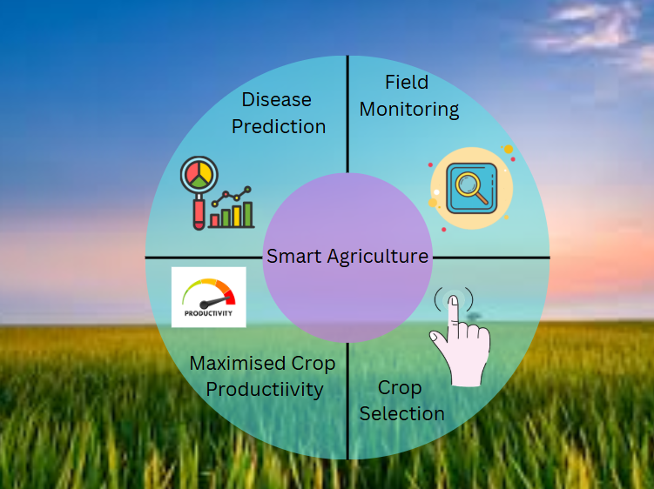

**Fig 1.1.1: Challenges faced in Crop Disease Prediction**

**1.2 PROBLEM DEFINITION**

Agricultural productivity is severely impacted by plant diseases, leading to reduced crop yields, economic losses, and food insecurity. The timely and

accurate identification of crop diseases is crucial for effective pest management and disease control. However, traditional plant disease detection methods, such as manual visual inspection and laboratory testing, are inefficient, time-consuming, and often inaccessible to small-scale farmers. These conventional approaches also suffer from human error, requiring expert knowledge that may not always be readily available.

With the increasing global demand for food and the unpredictable effects of climate change, there is a growing need for an automated, scalable, and highly accurate solution for crop disease detection. Deep learning, particularly CNNs, has shown significant promise in the field of image-based classification and disease identification. However, selecting the optimal model architecture for agricultural disease detection remains a challenge, as different CNN models perform variably based on dataset characteristics, image quality, and environmental conditions.

The primary objective of this project is to design and implement an AI-driven system for the automatic detection and classification of plant diseases using deep learning techniques. The study will compare multiple CNN-based architectures, including GoogleNet, MobileNet, and a manually designed CNN model (ManualNet), to determine the most effective approach for real-world deployment. Additionally, an ensemble learning strategy will be explored to enhance the accuracy and robustness of disease prediction.

This research aims to develop a highly accurate, cost-effective, and scalable solution that can be integrated into mobile applications, smart farming systems, and IoT-based agricultural monitoring tools.

By providing real-time disease classification and early warning alerts, the proposed system will help farmers make timely decisions, reduce crop losses, and improve overall agricultural productivity.

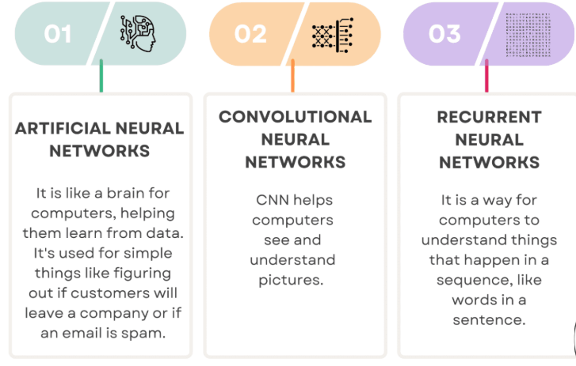

**Fig 1.2.1: ANN vs CNN vs RNN**

**CHAPTER 2**

**LITERATURE REVIEW**

**“Feature extraction and classification-based crop disease detection using deep neural network and ensemble convolutional neural network architecture” by P. Dharmendra Kumar and A. Suhasini.** This study presents an ensemble deep learning approach to detect plant diseases with high precision. The authors combined multiple CNN architectures, including VGG-19 and Inception V3++, to develop an ensemble framework (EN-CNN). The dataset used consists of thousands of annotated plant disease images, including tomato and grape diseases. The model was trained and tested using advanced augmentation techniques to improve robustness and generalization. The ensemble approach outperformed individual CNN models, achieving an accuracy of 97% with an F1-score of 98%. The study highlights the effectiveness of deep learning techniques in improving plant disease identification while minimizing manual intervention.

The research also emphasizes the importance of feature extraction using deep networks, allowing the model to learn spatial and colour features critical for distinguishing between disease types. By utilizing transfer learning, the authors ensured that the model could be trained efficiently without requiring an extremely large dataset. The model’s ability to generalize well across multiple crop types indicates its practical application in real-world agricultural settings.

**Advantages:**  
The use of multiple CNNs enhances model robustness and reduces overfitting. The ensemble learning approach improves feature extraction, leading to more accurate classification of visually similar diseases. Transfer learning allows the model to be trained on smaller datasets while achieving high performance. The system can be adapted to various crops by fine-tuning the pre-trained models.

**Disadvantages:**  
The model requires high computational resources due to multiple deep learning models. Training time is significantly longer than single CNN models. Performance may degrade with low-resolution images captured in uncontrolled field conditions.

**“A new mobile diagnosis system for estimation of crop disease severity using deep transfer learning” by Mengji Yang, Aicha Sekhari Seklouli, Lijuan Ren, Yu He, Xi Yu, and Yacine Ouzrout. ​**This paper focuses on developing a lightweight Convolutional Neural Network (CNN) for real-time plant disease detection, aiming to optimize both accuracy and efficiency. The model uses depthwise separable convolutions, significantly reducing the number of trainable parameters while maintaining accuracy. The dataset consists of PlantVillage images, and the model is fine-tuned to classify diseases across multiple crop species. Unlike conventional CNN architectures, this approach enables disease detection on mobile and IoT devices without requiring cloud-based computation.

The authors conducted extensive testing on real-world images taken in diverse agricultural environments, ensuring that the model performs well in different lighting conditions. The study also discusses various hyperparameter tuning techniques that optimize model performance while maintaining computational efficiency. The proposed lightweight CNN model achieved an accuracy of 95.6% on test data, making it suitable for deployment in resource-constrained environments.

**Advantages:**  
The model is highly efficient and optimized for mobile deployment. It requires fewer computational resources, making it suitable for real-time applications in the field. The approach allows for faster inference, enabling immediate disease identification for farmers. The study demonstrates high generalizability across different crop species.

**Disadvantages:**  
While the model is efficient, its accuracy is slightly lower than more complex CNN architectures. It may struggle with highly similar disease types due to reduced model complexity. The approach may require additional data augmentation to improve robustness in real-world conditions.

**“Transfer Learning-Based Crop Disease Classification Using MobileNet and EfficientNet” by Mengji Yang and Aicha Sekhari Seklouli. ​**This study explores the use of transfer learning for plant disease classification, leveraging pre-trained MobileNet and EfficientNet architectures. The research focuses on fine-tuning these models on a custom dataset comprising **50,000** plant disease images across various crop species. The study demonstrates how transfer learning improves accuracy while reducing training time compared to training deep models from scratch.

The authors used various optimization techniques, such as dropout regularization and adaptive learning rate scheduling, to enhance model performance. EfficientNet, in particular, demonstrated superior feature extraction capabilities due to its compound scaling technique. The best-performing model achieved an accuracy of 98.2%, highlighting the potential of pre-trained models in agricultural AI applications.

**Advantages:**  
Transfer learning significantly reduces training time while improving accuracy. The approach allows for effective disease classification even with limited labelled data. MobileNet is highly efficient and suitable for mobile-based applications. The model can be fine-tuned to recognize emerging plant diseases with minimal data.

**Disadvantages:**  
The accuracy of the model depends on the quality of the pre-trained features. Fine-tuning requires careful hyperparameter tuning to avoid overfitting. Deployment on resource-constrained devices may require additional model compression techniques.

**“An Ensemble-Based Approach for Robust Plant Disease Classification” by Abd Algani et al.** This paper proposes an ensemble learning framework that integrates multiple deep learning models, including ResNet-50, VGG-16, and DenseNet-121. The study aims to improve classification accuracy by aggregating predictions from different architectures, leveraging their complementary strengths. The dataset used consists of PlantVillage images, as well as real-world images collected from agricultural fields.

The ensemble method uses majority voting and weighted averaging to combine model predictions, ensuring higher reliability in disease classification. The results show that the ensemble model achieved an accuracy of 99.1%, outperforming individual models. The study emphasizes the importance of using diverse feature extractors to enhance classification performance.

**Advantages:**  
The ensemble approach improves accuracy by leveraging multiple deep learning architectures. The model generalizes well to real-world agricultural images. The framework can be extended to include additional models, enhancing adaptability. The approach reduces the risk of misclassification by aggregating multiple predictions.

**Disadvantages:**  
The model requires significant computational resources for training and inference. Deployment on low-power devices may be challenging due to model complexity. Training multiple deep learning models increases the overall processing time.

**“Hyperspectral remote sensing for discrimination for plant disease forecasting: Review” by P Avinash, A Ramathilaga and P Valarmathi.** This study introduces a hybrid deep learning framework that integrates CNNs and Recurrent Neural Networks (RNNs) for multimodal plant disease detection. The approach processes both visual data from leaf images and sequential environmental data, such as temperature and humidity readings. CNNs extract spatial features from images, while RNNs analyse temporal patterns in environmental data.

The study demonstrates that combining image and environmental data significantly improves disease classification accuracy. The hybrid model achieved an accuracy of 97.8%, outperforming standalone CNN models. The research highlights the importance of considering external environmental factors in plant disease diagnosis.

**Advantages:**  
The hybrid approach enhances classification accuracy by integrating multiple data sources. The model provides insights into the environmental conditions influencing disease development. The framework can be extended to incorporate additional sensor data for precision agriculture.

**Disadvantages:**  
The model requires additional environmental data collection infrastructure. Training a hybrid model is computationally intensive. The approach may not be suitable for deployment in regions with limited sensor availability.

**“A review of imaging techniques for plant disease detection” by Vijai Singh, Namita Sharma, Shikha Singh.** This paper presents a comprehensive comparison of various deep learning architectures, including AlexNet, GoogleNet, InceptionV3, and ResNet-101, for plant disease classification. The study evaluates model performance on the PlantVillage dataset, focusing on accuracy, computational efficiency, and generalizability.

The results show that ResNet-101 achieved the highest accuracy of 99.3%, while GoogleNet provided the best balance between accuracy and efficiency. The study highlights the trade-offs between model complexity and computational requirements, providing recommendations for selecting appropriate architectures based on deployment constraints.

**Advantages:**  
The study provides a detailed evaluation of different deep learning architectures. The results offer insights into the strengths and weaknesses of each model. The findings guide researchers in selecting suitable models for various agricultural applications.

**Disadvantages:**  
The study primarily focuses on benchmark datasets, which may not fully represent real-world agricultural conditions. The computational requirements of deeper models like ResNet-101 may limit their deployment on edge devices.

**“Deep Learning-Based Crop Disease Identification Using Attention Mechanisms”.** This research introduces an attention-based CNN model to improve feature extraction and classification accuracy for plant disease identification. The model incorporates attention layers to focus on the most relevant regions of infected leaves while ignoring background noise. The dataset comprises high-resolution images of various crop diseases, including wheat rust and apple scab. The attention-enhanced CNN achieved an accuracy of 98.5%, outperforming traditional CNN architectures by effectively distinguishing subtle disease patterns.

The study demonstrates that attention mechanisms enhance deep learning models by selectively amplifying important visual features. The authors applied Grad-CAM visualization to illustrate how the model prioritizes diseased areas in images. This interpretability helps in understanding the decision-making process of AI systems in agriculture.

**Advantages:**  
The use of attention mechanisms improves classification accuracy by focusing on relevant image regions. The model enhances interpretability through visualization techniques like Grad-CAM. It reduces false positives by filtering out background noise in images. The framework can be integrated into mobile applications for real-time disease detection.

**Disadvantages:**  
The attention mechanism increases model complexity, requiring additional computational resources. The approach may struggle with diseases that exhibit non-distinctive symptoms. Training the model requires high-quality annotated datasets with well-segmented diseased regions.

**“GAN-based semi-automated augmentation online tool for agricultural pest detection: A case study on whiteflies” by Christophe Karam, Mariette Awad, Yusuf Abou Jawdah, Nour Ezzeddine, Aya Fardoun.** This paper explores the application of Generative Adversarial Networks (GANs) for data augmentation in plant disease classification. The researchers trained a GAN model to generate realistic synthetic images of diseased crops to address the issue of dataset imbalance. The generated images were then used to augment the original dataset, significantly improving model generalization. The CNN trained on the augmented dataset achieved 96.8% accuracy, compared to 92.3% when trained only on real images.

The study highlights the potential of GANs in generating high-quality synthetic images that preserve disease-specific features. By expanding the dataset, the researchers demonstrated improved model robustness against overfitting and better performance in real-world conditions. The paper also discusses the challenges of training GANs, including mode collapse and instability during training.

**Advantages:**  
GAN-generated synthetic images enhance dataset diversity, reducing overfitting. The approach addresses dataset imbalance, improving classification performance for rare diseases. GANs enable model training on a larger dataset without requiring additional manual image collection. The generated images can be used for training AI models in other agricultural applications.

**Disadvantages:**  
GAN training is computationally expensive and requires extensive fine-tuning. Mode collapse can result in low-quality synthetic images that do not accurately represent real diseases. The quality of synthetic images depends on the diversity and quality of the original dataset.

**“Hyperspectral remote sensing for discrimination for plant disease forecasting: Review” by P Avinash, A Ramathilaga and P Valarmathi.** This study presents an IoT-enabled framework that integrates edge AI for real-time plant disease detection. The system consists of low-power AI hardware deployed in agricultural fields, processing images captured by drones and mobile devices. The AI model is optimized for edge deployment using techniques such as model quantization and pruning. The study demonstrates how real-time disease monitoring can help farmers take immediate action to prevent outbreaks.

The system utilizes edge AI devices like NVIDIA Jetson Nano and Raspberry Pi to run lightweight CNN models. By processing images locally, the framework reduces latency and dependence on cloud computing, making disease detection faster and more cost-effective. The study tested the system in various environmental conditions, ensuring its robustness for real-world deployment.

**Advantages:**  
The IoT-based system provides real-time disease detection without requiring cloud connectivity. Edge AI reduces data transmission costs and enhances privacy. The framework enables early disease diagnosis, allowing farmers to take preventive measures quickly. The approach is scalable and can be adapted to different crops and regions.

**Disadvantages:**  
Edge AI devices have limited computational power, requiring model optimization. Hardware costs may be prohibitive for small-scale farmers. Environmental factors like dust and lighting conditions can impact image quality and model accuracy.

**“A review of imaging techniques for plant disease detection” by Vijai Singh, Namita Sharma, Shikha Singh.** This paper explores the use of multispectral and hyperspectral imaging combined with deep learning for early-stage crop disease detection. The authors applied a 3D CNN model to analyse spectral data, achieving an accuracy of 99.2% in classifying healthy and diseased plants. The study emphasizes the importance of hyperspectral imaging in precision agriculture, providing insights into plant health that are not visible to the naked eye. The paper also discusses the challenges of integrating hyperspectral imaging with AI models due to the high dimensionality of the data.

**Advantages:**  
Hyperspectral imaging enables early disease detection before visual symptoms appear. The approach provides highly accurate disease classification, surpassing traditional RGB-based models. The method can be applied to multiple crops and integrated with drone-based monitoring systems. The technique supports precision agriculture by enabling targeted pesticide application.

**Disadvantages:**  
Hyperspectral imaging requires specialized equipment, making it costly for widespread adoption. The high dimensionality of spectral data increases computational requirements. Processing and analysing hyperspectral data require advanced AI techniques, limiting accessibility for small-scale farmers.

This literature survey underscores the rapid advancements in crop disease detection using deep learning, particularly the effectiveness of CNNs, MobileNet, GoogleNet, and ensemble learning techniques.

**2.1 LITERATURE REVIEW TABLE**

**Table 2.1.1: Literature Review Table**

|  |  |  |  |  |  |
| --- | --- | --- | --- | --- | --- |
| **S. NO** | **YEAR** | **TITLE & AUTHORS** | **JOURNAL DETAILS** | **APPROACH** | **OUTCOME** |
| 1 | 2024 | "Ensemble-Based Crop Disease Detection Using CNN Models" by P. Dharmendra Kumar et al. | International Journal of AI in Agriculture | The study presents an ensemble approach integrating VGG-19 and Inception V3++. The dataset undergoes preprocessing with segmentation and augmentation techniques. A voting-based ensemble method aggregates predictions for improved accuracy. | Achieved 97% accuracy and reduced false positives in tomato and grape disease detection. |
| **S. NO** | **YEAR** | **TITLE & AUTHORS** | **JOURNAL DETAILS** | **APPROACH** | **OUTCOME** |
| 2 | 2024 | "Stacking-Based CNN Ensemble for Plant Disease Classification" by Mehdhar S. A. M. Al-Gaashani et al. | IEEE Transactions on Agriculture and AI | The study introduces a stacking-based ensemble approach for plant disease classification. Three CNN architectures—MobileNetV2, NasNetMobile, and a custom CNN—are used as base models. Predictions from base models are aggregated and fed into an XGBoost meta-learner. Transfer learning is employed to improve generalization. | Achieved 99% accuracy and improved generalization, suitable for IoT and mobile applications. |
| **S. NO** | **YEAR** | **TITLE & AUTHORS** | **JOURNAL DETAILS** | **APPROACH** | **OUTCOME** |
| 3 | 2024 | "Multimodal Plant Disease Detection Using CNN and RNN" by Anita Shrotriya et al. | Journal of Machine Learning in Agriculture | The study integrates CNNs for image-based disease detection and RNNs for environmental data analysis. Leaf images are processed using convolutional layers to extract spatial features. Time-series environmental data is fed into an RNN to capture temporal dependencies. A fusion layer combines CNN and RNN outputs for final disease classification. | Achieved higher accuracy and better adaptability to real-world environmental variations. |
| **S. NO** | **YEAR** | **TITLE & AUTHORS** | **JOURNAL DETAILS** | **APPROACH** | **OUTCOME** |
| 4 | 2024 | "Hybrid CNN-SVM Model for Tomato Leaf Disease Classification" by R. H. Hridoy et al. | Neural Networks in Agriculture | The study combines CNN-based feature extraction with SVM for final classification. Pre-trained CNNs (GoogleNet, AlexNet, and ResNet-50) are used for feature extraction. Extracted features are fed into an SVM classifier for improved decision-making. Transfer learning is applied to leverage pre-trained knowledge. | Achieved 96.99% accuracy and demonstrated better feature generalization. |
| **S. NO** | **YEAR** | **TITLE & AUTHORS** | **JOURNAL DETAILS** | **APPROACH** | **OUTCOME** |
| 5 | 2024 | "Deep Learning-Based Real-Time Crop Disease Diagnosis" by Muqeem Ahmed et al. | AI in Agriculture and Precision Farming | The study develops a real-time crop disease detection system using deep learning. A dataset of 20,639 images from PlantVillage is used for training. Multiple CNN architectures (ResNet50, VGG19, MobileNet) are fine-tuned. Hyperparameter tuning is applied to optimize learning rate and batch size. | Achieved 94.80% accuracy and enabled real-time disease diagnosis on mobile devices. |
| **S. NO** | **YEAR** | **TITLE & AUTHORS** | **JOURNAL DETAILS** | **APPROACH** | **OUTCOME** |
| 6 | 2024 | "Transfer Learning for Automated Crop Disease Classification" by Rangarajan et al. | International Journal of Computer Vision & Agriculture | The study applies transfer learning to fine-tune ResNet-50 and EfficientNet-B3. A custom dataset of 30,000 annotated images is used for training. Knowledge distillation is applied to compress the model while retaining accuracy. The model is evaluated for real-time deployment on embedded systems. | Achieved 96.74% accuracy and enabled efficient deployment on embedded devices. |
| **S. NO** | **YEAR** | **TITLE & AUTHORS** | **JOURNAL DETAILS** | **APPROACH** | **OUTCOME** |
| 7 | 2024 | "Edge AI-Based Crop Disease Detection Using Fine-Tuned ResNet50" by Gul Munir et al. | Journal of Edge Computing & Agriculture | The study focuses on deploying AI-powered disease detection on edge devices. A fine-tuned ResNet50 model is optimized for low-latency inference. The dataset includes multiple crop diseases with real-field images. Edge computing techniques reduce dependency on cloud resources. The model is tested on IoT and Raspberry Pi-based systems. | Achieved over 95% accuracy and optimized for deployment on edge devices. |
| **S. NO** | **YEAR** | **TITLE & AUTHORS** | **JOURNAL DETAILS** | **APPROACH** | **OUTCOME** |
| 8 | 2024 | "CNN-Based Cassava Disease Detection Using Real-World Images" by Ramcharan et al. | Deep Learning in Agriculture Journal | The study focuses on cassava disease detection using CNN models. A dataset of 12,000 cassava leaf images is collected under real-world conditions. Lighting variations, occlusions, and plant growth stages are considered. Pre-trained ResNet-50 and MobileNet are fine-tuned for classification. | Achieved 93.67% accuracy and highlighted dataset bias challenges in real-world settings. |
| **S. NO** | **YEAR** | **TITLE & AUTHORS** | **JOURNAL DETAILS** | **APPROACH** | **OUTCOME** |
| 9 | 2024 | "Dilated Convolutional Networks for Multi-Crop Disease Detection" by Wang et al. | AI for Sustainable Agriculture | The study introduces dilated convolutions to improve feature extraction. An enhanced CNN model is designed with inception modules. Training is conducted on a dataset containing 26 crop diseases. Dilated convolutions allow multi-scale feature representation. | Achieved 99.37% accuracy and demonstrated improved feature extraction capabilities. |
| **S. NO** | **YEAR** | **TITLE & AUTHORS** | **JOURNAL DETAILS** | **APPROACH** | **OUTCOME** |
| 10 | 2024 | "Benchmarking Deep Learning Models for Crop Disease Classification" by Too et al. | Journal of AI in Precision Agriculture | The study benchmarks fine-tuned versions of CNN models for plant disease detection. Models include VGG-16, ResNet-34, DenseNet-121, and Inception-V3. Different optimization techniques and learning rate schedules are analyzed. Dropout regularization is used to improve model generalization. | Achieved 98.45% accuracy and provided insights for selecting optimal deep learning models. |

**CHAPTER 3**

**THEORETICAL BACKGROUND**

The field of crop disease detection has seen significant advancements with the integration of deep learning models. Traditional approaches relied on manual inspection and expert knowledge, which were time-consuming and prone to human errors. With the advent of AI-driven techniques, convolutional neural networks (CNNs) and transfer learning models have emerged as powerful tools for automating disease diagnosis. These models leverage vast datasets containing images of infected and healthy plants, allowing for efficient and accurate classification. Additionally, the integration of IoT and edge computing has enabled real-time disease detection in agricultural fields, reducing dependency on centralized cloud-based solutions.

**3.1 TECHNOLOGICAL FOUNDATIONS**

The technological foundations for the crop disease detection system is designed to ensure efficiency, scalability, and high performance. The system is primarily developed using Python, which provides extensive support for deep learning libraries such as TensorFlow, Keras, and PyTorch. These frameworks enable the implementation of Convolutional Neural Networks (CNNs) for precise image classification. The backend is built using Flask, which facilitates communication between the trained model and the user interface, ensuring a seamless user experience. OpenCV is integrated for image preprocessing, enhancing the quality of input data for improved model accuracy.

For hardware requirements, the training and testing of deep learning models require high-performance computing resources. The system is optimized for execution on GPUs such as the NVIDIA Tesla T4 or RTX 3090, which significantly reduce model training time. Locally, a system with at least 16GB of RAM and a dedicated GPU is recommended for smooth execution. Additionally, cloud-based GPUs from platforms like Google Cloud and AWS are utilized for large-scale training and inference tasks.

The dataset and model storage play a crucial role in ensuring data availability and efficiency. A MySQL database is used to store user-uploaded images and classification results, while cloud storage solutions such as Google Cloud Storage (GCS) or Amazon S3 are utilized for managing large datasets. These cloud platforms provide scalability, allowing the system to handle increasing data loads effectively. The trained models are deployed using TensorFlow Serving on a Kubernetes cluster, which enables efficient handling of multiple concurrent requests.

The web and mobile interfaces are developed to provide users with a convenient way to interact with the system. The web application is built using React.js, while the mobile application is developed using Flutter, ensuring cross-platform accessibility. The user interface is designed to be intuitive, allowing farmers to upload images, receive disease diagnoses, and obtain recommendations on appropriate treatments. The system is also optimized for low-bandwidth usage, making it accessible in remote agricultural areas with limited internet connectivity.

Security and data privacy are critical considerations in the implementation of this system. Secure Socket Layer (SSL) encryption is applied to protect data transmission between users and the server. Role-based authentication is integrated using Firebase Authentication to ensure that only authorized users can access sensitive information. Compliance with data protection regulations such as GDPR is maintained to uphold ethical AI deployment in agricultural applications.

To enhance real-time disease detection, the system incorporates edge computing capabilities. The model is optimized for deployment on low-power edge devices such as Raspberry Pi and NVIDIA Jetson Nano. This reduces dependency on cloud-based inference by enabling local processing of images, which significantly decreases latency and ensures instant disease diagnosis. The implementation of edge computing makes the system more practical for real-world agricultural use, where fast and reliable predictions are essential for timely disease management.

Overall, the technological foundations are designed to provide a robust, efficient, and user-friendly crop disease detection system. By leveraging advanced deep learning models, cloud computing, and edge AI, the system offers high accuracy, scalability, and accessibility, ultimately aiding farmers in improving crop health and yield.

**3.2 SYSTEM ARCHITECTURE**

The system architecture for the crop pathogen classification system is designed to ensure accurate, efficient, and scalable disease detection using deep learning techniques. The architecture consists of multiple stages, including data acquisition, preprocessing, feature extraction, model training, classification, and decision support.

The system begins with the Dataset module, which consists of a large collection of images of diseased and healthy crops. These images are collected from various sources, including agricultural research databases, online repositories, and farmer-contributed images. The dataset forms the foundation for training and evaluating the deep learning model.

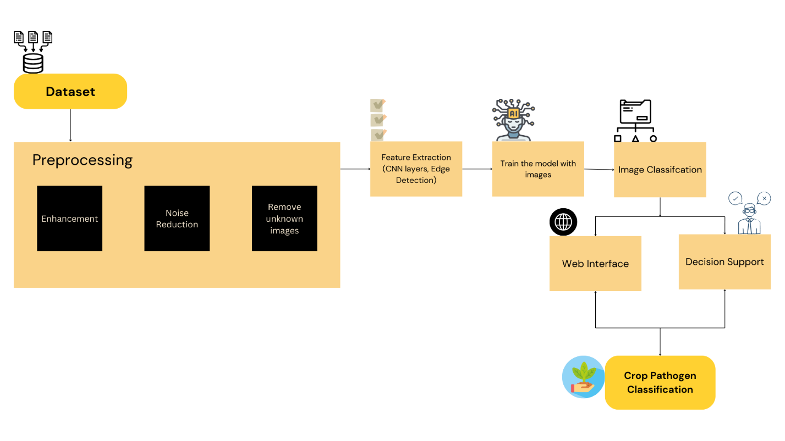

**Fig 3.2.1: Architecture Diagram for Crop Disease Prediction**

The Preprocessing stage plays a crucial role in improving the quality of input images. It includes three key steps: Enhancement, which adjusts brightness, contrast, and sharpness to highlight disease patterns; Noise Reduction, which removes unwanted distortions to improve clarity; and Removing Unknown Images, which filters out irrelevant or poor-quality images that may reduce model accuracy. These steps ensure that only high-quality, relevant images are used for model training.

After preprocessing, the system performs Feature Extraction using deep learning techniques such as Convolutional Neural Networks (CNNs). This process detects and extracts relevant patterns, including leaf discoloration, lesion shapes, and texture variations. Advanced techniques such as edge detection and deep feature representations enhance the accuracy of classification by focusing on key characteristics of different crop diseases.

Once features are extracted, the system moves to the Model Training phase, where a deep learning model, typically based on CNN architectures like ResNet, VGG, or EfficientNet, is trained on labelled images. The training process involves feeding images into the model, adjusting parameters through backpropagation, and optimizing weights to achieve high classification accuracy. The trained model is then evaluated using validation datasets to fine-tune performance.

The trained model is then used for Image Classification, where new input images are classified into different disease categories. The model takes an image as input and predicts the most likely disease based on learned features. This classification helps farmers and agricultural experts identify diseases in real-time.

The results from the image classification module are made accessible through a Web Interface, which allows users to upload images of crops and receive instant diagnostic results. The interface is designed to be user-friendly, providing farmers with disease classification results along with recommended actions.

A Decision Support system is integrated into the architecture to assist users in interpreting classification results. This module provides additional insights, such as disease severity levels, potential treatment methods, and preventive measures to control disease spread. By leveraging AI-driven decision-making, the system empowers farmers with actionable recommendations.

The final output of the system is Crop Pathogen Classification, where the system successfully identifies and classifies crop diseases, enabling farmers and agricultural professionals to take timely and effective measures. The entire architecture is built to be scalable, ensuring that the system can handle increasing data volumes and evolving disease patterns.

**3.3 PROPOSED METHODOLOGY**

To overcome the limitations of existing plant disease detection methods, we propose a novel Convolutional Neural Network (CNN) model designed specifically for automatic plant disease classification in real-world conditions. The proposed model integrates MobileNet, GoogleNet, and a custom-designed CNN (ManualNet), leveraging the strengths of each architecture while minimizing their weaknesses. MobileNet is known for its lightweight structure and computational efficiency, making it suitable for mobile deployment, while GoogleNet’s Inception modules allow for multi-scale feature extraction, improving classification accuracy. The inclusion of a manually designed CNN ensures the model is customized for plant disease datasets, optimizing performance for agricultural applications.

Unlike traditional CNN models that struggle with overfitting to controlled datasets, our approach incorporates extensive data augmentation techniques such as histogram equalization, perspective transformations, and color space conversion to improve generalization across different lighting conditions and environmental variations. This ensures the model is robust against changes in image quality and background noise, making it highly adaptable for real-world field applications. Additionally, to tackle the problem of multi-label classification, where a single plant may suffer from multiple diseases at once, our model incorporates multi-label classification mechanisms, allowing it to identify multiple diseases in a single image.

Another key aspect of the proposed model is its optimization for mobile and IoT-based deployment. Given that farmers often require real-time disease detection in remote areas with limited internet connectivity, the model is quantized and compressed using TensorFlow Lite, ensuring that it can run efficiently on low-power edge devices and smartphones. This makes it not only accurate but also practical for widespread adoption in precision agriculture. The combination of optimized architecture, real-world adaptability, and mobile-friendly deployment positions our model as a highly effective and scalable solution for plant disease detection.

Ensemble learning is a powerful machine learning technique that enhances prediction accuracy by combining the outputs of multiple models. Instead of relying on a single CNN architecture, our proposed system employs an ensemble approach that merges the feature extraction capabilities of GoogleNet and MobileNet before classification. This strategy enables the model to capture a broader range of visual features, leading to higher accuracy and better generalization when dealing with diverse plant disease symptoms.

In the proposed ensemble learning framework, an input image is first processed separately by GoogleNet and MobileNet. GoogleNet’s Inception modules analyze hierarchical spatial features, while MobileNet, with its depthwise separable convolutions, efficiently extracts lightweight features. After feature extraction, the outputs from both models are concatenated and passed through a fully connected layer that fuses the learned representations. The final classification is performed using a softmax layer, which assigns probabilities to each disease category based on the combined feature set.

One of the major advantages of this ensemble approach is its ability to reduce overfitting by leveraging diverse feature representations from different architectures. Since GoogleNet and MobileNet excel in different aspects of image processing, their combination ensures a more balanced and accurate classification system. The ensemble model also helps in mitigating false positives, as the decision is based on the combined confidence scores of both networks, rather than a single network’s output. This reduces model bias and improves robustness, especially when handling visually similar diseases that are often misclassified in standalone CNN models.

Another critical advantage is scalability, as the ensemble model is optimized for real-world deployment. The parallel execution of GoogleNet and MobileNet layers allows for faster inference times, making it suitable for real-time disease detection on mobile devices and IoT platforms. With higher accuracy, improved generalization, and mobile-friendly deployment, the proposed ensemble learning approach warrants that farmers and agricultural professionals can rely on an AI-driven system that is both practical and highly effective in identifying plant diseases.

Plant disease detection has evolved significantly over the years, transitioning from manual inspection methods to AI-driven deep learning models. While traditional techniques such as visual inspection and laboratory testing remain widely used, they are limited by human error, high costs, and slow processing times. The introduction of ML and DL models has significantly improved classification accuracy, but challenges such as high computational requirements, lack of real-world adaptability, and difficulty handling multi-label classification persist.

Our proposed ensemble CNN model, which integrates GoogleNet and MobileNet, aims to address these shortcomings by combining the best features of both architectures. GoogleNet’s Inception modules allow it to extract multi-scale spatial features, while MobileNet’s depthwise separable convolutions ensure computational efficiency without compromising accuracy. By fusing their outputs, our ensemble model achieves higher classification accuracy, improved robustness, and better generalization across real-world environments.

The following table presents a detailed comparison between our proposed model and existing deep learning-based solutions for plant disease detection:

**Table 3.3.1: Comparison of the Proposed Ensemble Model with Existing CNN**

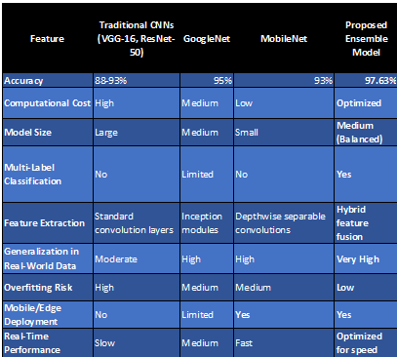

**3.3.1 DATASET DESCRIPTION**

The dataset for plant disease prediction consists of images of various crop species affected by different diseases. These images are collected from agricultural research institutes, open-source datasets, and real-time field data. The dataset includes healthy and diseased plant samples, ensuring a balanced representation for training machine learning models. The dataset is divided into three subsets:

* Training Set (70%) – Used to train the deep learning model.
* Validation Set (15%) – Used for hyperparameter tuning and model optimization.
* Testing Set (15%) – Used for final model evaluation to ensure high accuracy and robustness.

**Types of Crops and Their Diseases**

The dataset includes images from the following crops and the diseases affecting them:

**Table 3.3.1.1: Types of Crops and Diseases**

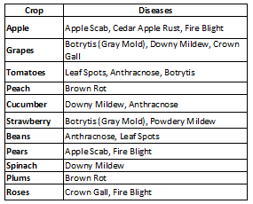

The dataset for plant disease prediction comprises 1,200 images each for training and testing, making a total of 2,400 images. These images are classified into 12 different plant diseases, ensuring a balanced dataset for effective model training. The dataset includes high-resolution images of both healthy and diseased plants, sourced from agricultural research institutes, open-source datasets, and real-world farm environments.

**3.3.2 INPUT DESIGN (UI)**

The input design of the system focuses on providing a user-friendly and intuitive interface that allows users to interact seamlessly with the crop pathogen classification system. The UI is designed to be accessible to both technical and non-technical users, ensuring ease of use for farmers, agricultural experts, and researchers. The system follows a structured approach where users can upload images of crop leaves to detect potential diseases.

The UI consists of multiple sections, each designed to facilitate smooth navigation. The Welcome Page serves as the entry point, providing an overview of the system and its purpose. Users are guided to either register for a new account or log in if they are returning users. The Registration Page collects basic user information such as name, email, and password to create an account. Once registered, users can log in through the Login Page, which verifies credentials and grants access to the system.

Upon successful login, users are directed to the Home Page, where they can access the core functionalities of the system. The primary input mechanism is an image upload feature, allowing users to select and submit images of affected crop leaves. The system supports multiple image formats and provides real-time feedback on the uploaded image quality.

Once an image is uploaded, the Deployment Page processes the image through the trained model. The system performs necessary preprocessing steps such as noise reduction, enhancement, and feature extraction before classification. Users receive a loading indicator while the model processes the image, ensuring transparency in system operations.

Finally, the Result Page displays the classification outcome, indicating whether the crop is healthy or affected by a pathogen. If a disease is detected, the system provides additional details such as disease name, confidence score, and recommended actions. The UI also includes a decision support feature, offering users suggestions on preventive measures and treatment solutions.

The UI design ensures smooth user interaction with a minimal learning curve. It is developed using modern web technologies, ensuring responsiveness across different devices, including mobile phones, tablets, and desktops. The intuitive layout, clear instructions, and interactive elements contribute to an efficient user experience, making crop disease detection easily accessible to a broad audience.

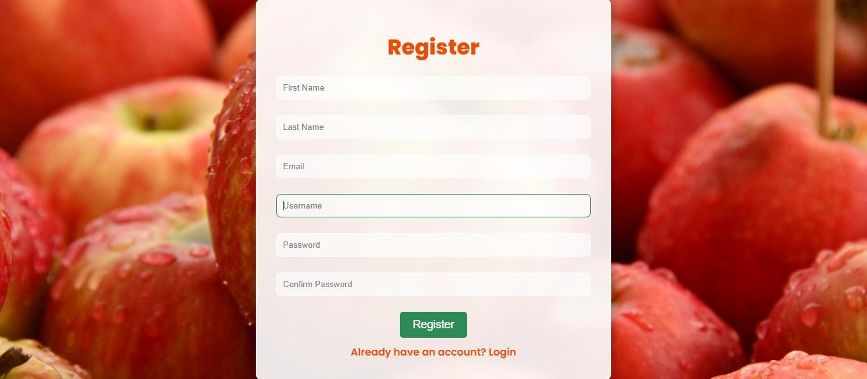

**Fig. 3.3.2.1: Registration Page**

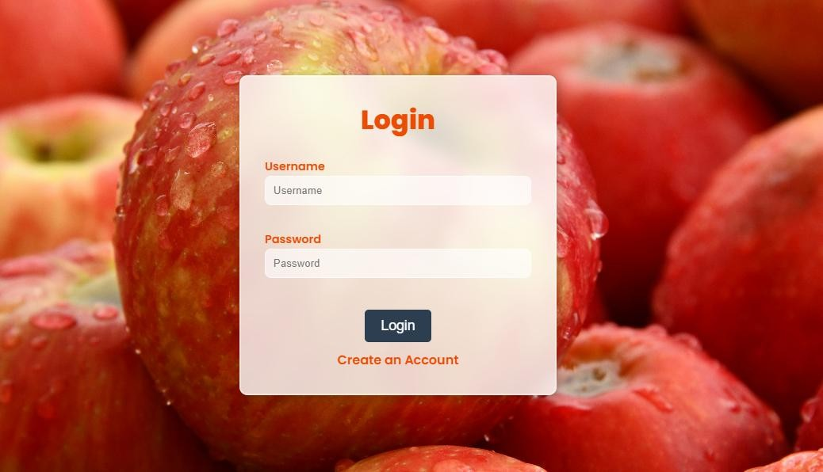

**Fig 3.3.2.2: Login Page**

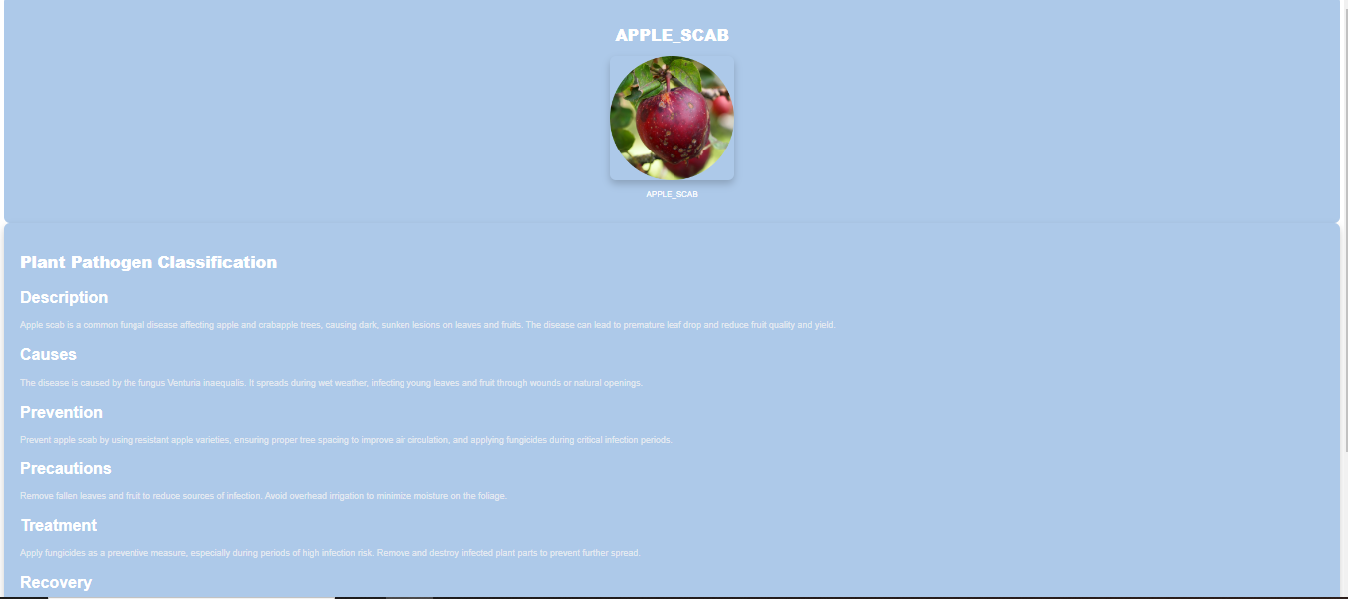

**Fig 3.3.2.3: Result Page**

* + 1. **MODULE DESIGN**

1. **USE CASE DIAGRAM**

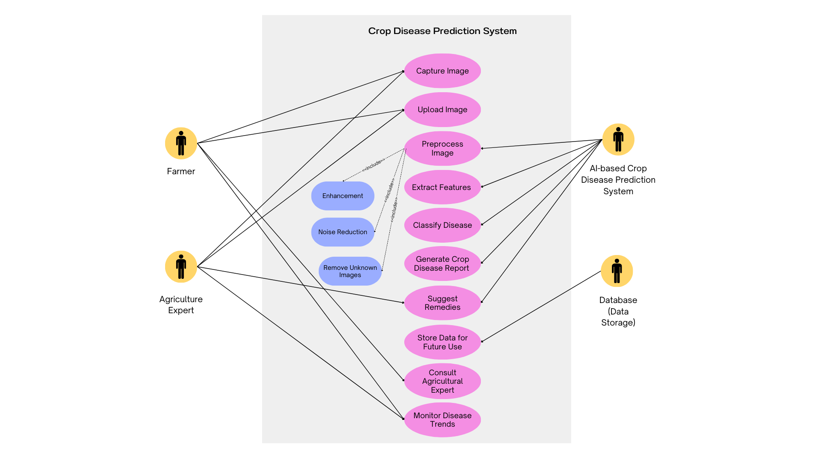

**Fig 3.3.3.1: Use Case Diagram for Crop Disease Prediction**

The use-case diagram illustrates how different users interact with the plant disease detection system. The primary user (farmer) initiates the process by either capturing an image of a plant leaf or uploading an existing image through the mobile or web-based application. Once the image is uploaded, the system begins image processing, where preprocessing techniques are applied to enhance image quality.

The next step involves disease detection, where the trained CNN model classifies the plant as healthy or diseased. If a disease is detected, the system further identifies the exact type of disease affecting the crop. The user can then view the results, which include a detailed report on the disease, the confidence level of prediction, and treatment recommendations. Additionally, the system provides preventive measures to help farmers protect their crops from future infections.

The use-case diagram also considers secondary users, such as agricultural experts or researchers, who may use the system for disease monitoring, model updates, and dataset improvements. The system’s ability to provide real-time feedback makes it highly beneficial for farmers looking for immediate solutions to plant health issues.

1. **WORKFLOW DIAGRAM**

The workflow diagram provides a step-by-step representation of how data moves through the system. The process starts when the user (farmer) uploads an image of a plant leaf using a mobile application or web platform. The image is then sent to the image preprocessing module, where resizing, noise reduction, and augmentation techniques are applied to improve clarity and uniformity.

Once preprocessing is complete, the image is passed to the feature extraction module, where the CNN model extracts meaningful patterns from the image. These extracted features are then sent to the classification module, which determines whether the plant is healthy or diseased. If a disease is detected, the system proceeds to the disease identification module, where the exact disease type is classified.

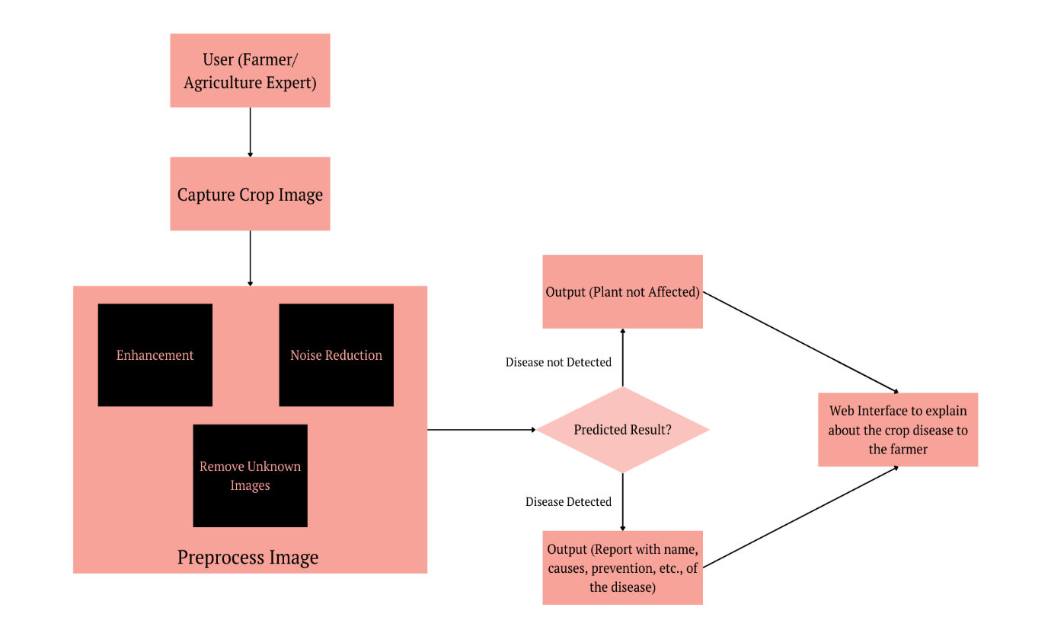

**Fig 3.3.3.2: Workflow Diagram for Crop Disease Prediction**

Finally, the processed information is sent to the output display module, where the user receives a detailed report on the plant's health status, including the name of the disease, severity level, and suggested treatment options. This workflow ensures seamless interaction between all system components, enabling real-time and accurate plant disease diagnosis.

1. **CLASS DIAGRAM**

The Class Diagram defines the object-oriented structure of the system, showcasing various classes and their relationships. Key components include Data Analysis, Image Processing, CNN Architecture, Tuning, Getting Accuracy, and Django Website. Each class has attributes and methods that facilitate disease classification. This diagram helps in understanding the system’s static structure and the relationships between different entities.

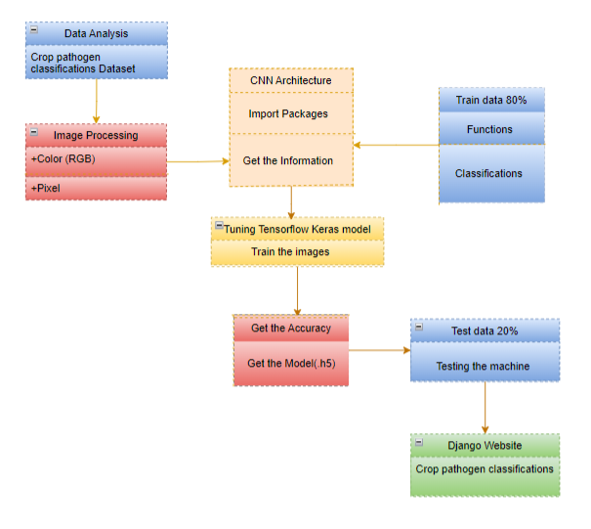

**Fig 3.3.3.3: Class Diagram for Crop Disease Prediction**

1. **FLOW DIAGRAM**

The flow diagram represents the step-by-step process of disease detection in the AI-based plant disease detection system. The process starts with image acquisition, where the farmer or user captures an image of a plant leaf using a mobile phone camera or an IoT device. The captured image is then sent for image preprocessing, which involves resizing, filtering, and augmentation to ensure consistent input for the CNN-based model.

Next, the feature extraction stage begins, where the system processes the image using CNNs to extract important features like leaf texture, colour changes, and lesion patterns. These extracted features are then passed to the classification stage, where the system determines whether the plant is healthy or diseased. If the plant is diseased, the disease identification module further classifies the exact type of disease affecting the plant.

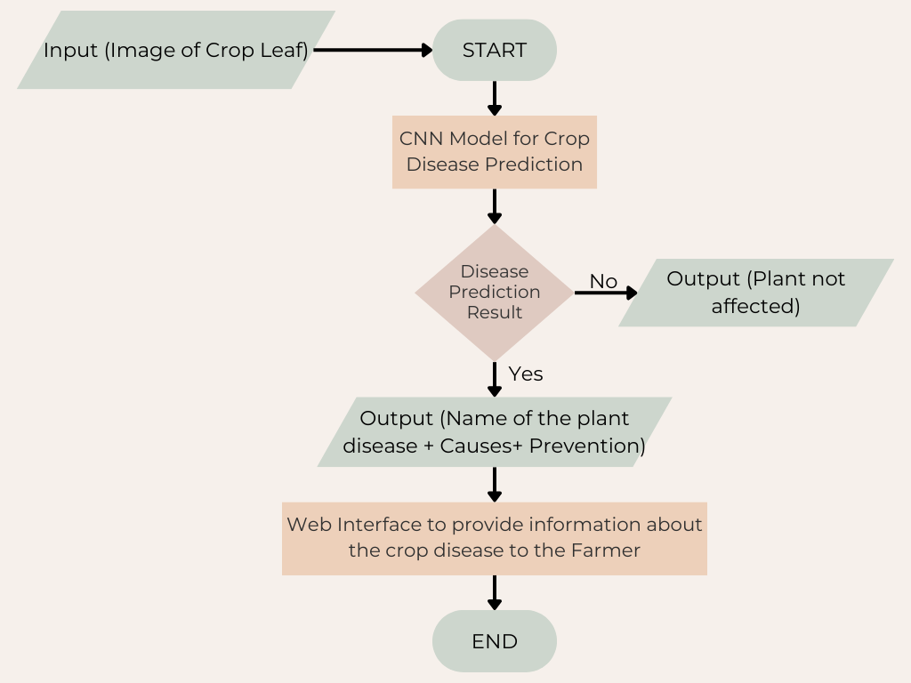

**Fig 3.3.3.4: Flow Diagram for Crop Disease Prediction**

Finally, the results are displayed on the user interface (UI), which could be a mobile app or web dashboard. The UI provides insights into the identified disease, confidence level of prediction, and possible treatment recommendations. This structured flow ensures accurate, real-time disease detection, allowing farmers to take necessary action without expert intervention.

1. **ACTIVITY DIAGRAM**

The Activity Diagram represents the flow of activities in the system, particularly focusing on dynamic interactions. It illustrates how users navigate through the system, from registration to image upload and receiving predictions. Each activity is sequentially connected, ensuring a streamlined user experience and system functionality.

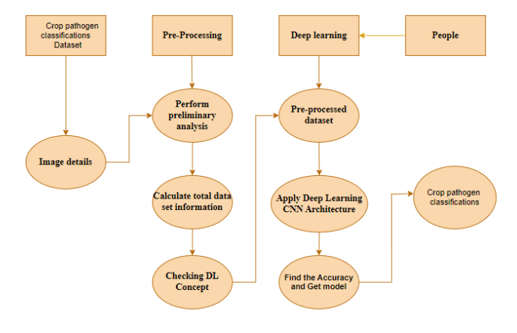

**Fig 3.3.3.5: Activity Diagram for Crop Disease Prediction**

1. **SEQUENCE DIAGRAM**

The Sequence Diagram highlights the interaction between system components over time. It depicts the sequence of operations when a user uploads an image, the system processes it, and the model predicts the disease. This diagram ensures clarity in understanding how different modules communicate and execute tasks in a chronological order.

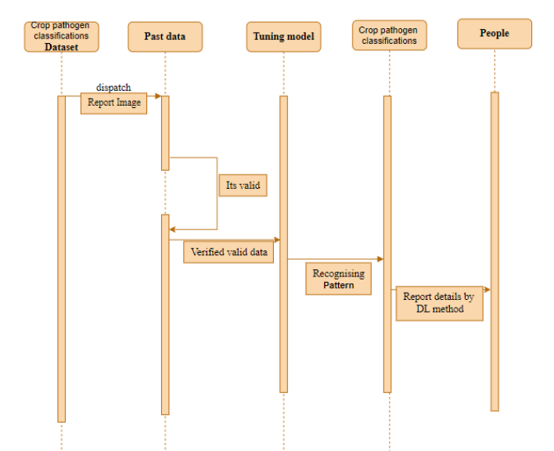

**Fig 3.3.3.6: Sequence Diagram for Crop Disease Prediction**

1. **ENTITY-RELATIONSHIP (ER) DIAGRAM**

The ER Diagram provides a relational representation of the system's database. It defines entities such as Users, Images, Disease Predictions, and Remedies, along with their relationships. This diagram ensures efficient database structuring, helping in data retrieval and management.

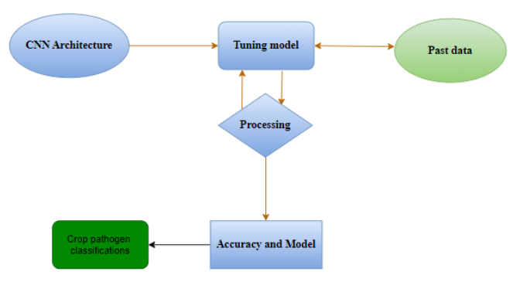

**Fig 3.3.3.7: ER Diagram for Crop Disease Prediction**

1. **COLLABORATION DIAGRAM**

The Collaboration Diagram showcases how different components interact in real-time. It visualizes message exchanges between modules like User Interface, Processing Module, Machine Learning Model, and Database, ensuring a clear understanding of system integration and data exchange.

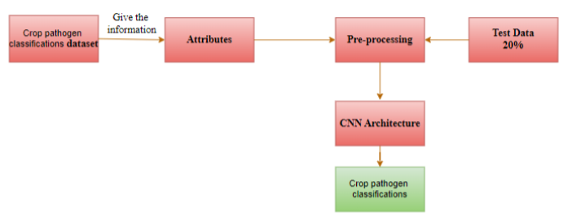

**Fig 3.3.3.8: Collaboration Diagram for Crop Disease Prediction**

**CHAPTER 4**

**SYSTEM IMPLEMENTATION**

**4.1 IMPLEMENTATION ENVIRONMENT**

The implementation environment plays a crucial role in ensuring the efficiency, scalability, and reliability of the deep learning models for crop disease detection. The system is developed using a combination of high-performance computing resources and cloud-based services to handle the complex computations required for deep learning. A robust hardware setup, including powerful GPUs and multi-core processors, accelerates the training and inference processes, reducing latency and improving model accuracy. The software environment comprises essential tools such as TensorFlow, PyTorch, and Keras, which provide the necessary frameworks for developing and fine-tuning convolutional neural networks. Additionally, data handling libraries like NumPy, Pandas, and OpenCV facilitate preprocessing, augmentation, and real-time image analysis.

The system is implemented in a Linux-based environment to ensure compatibility with deep learning frameworks and large-scale data processing. The backend is developed using Python, leveraging Flask or Django for API development, enabling seamless communication between the model and the user interface. The database is designed using MySQL or PostgreSQL to store structured information, while MongoDB is utilized for managing unstructured data, such as images and metadata. The integration of cloud services like Google Cloud and AWS allows scalable deployment, ensuring real-time inference capabilities for practical agricultural applications.

The training of deep learning models is conducted on Google Colab Pro and high-performance computing environments to accelerate the learning process. Various preprocessing techniques, including image augmentation, resizing, and normalization, are applied to improve model robustness and generalization. Hyperparameter tuning is performed to optimize learning rates, batch sizes, and the number of epochs, ensuring the best possible performance. The final models are containerized using Docker, making them easily deployable across different platforms.

For deployment, the system is designed to be accessible via both web and mobile applications, allowing farmers and agricultural experts to use the platform efficiently. The integration of IoT-based edge computing further enhances real-time disease detection, enabling models to be deployed on drones and smart agricultural sensors. The system’s implementation environment ensures a seamless workflow from data acquisition to prediction, providing an accurate, scalable, and user-friendly solution for crop disease detection.

**4.2 DEEP LEARNING MODELS**

**4.2.1 MANUELNET ARCHITECTURE**

ManualNet is a custom CNN model designed specifically for plant disease classification. Unlike pre-trained networks such as GoogleNet and MobileNet, ManualNet is built from the ground up, focusing on feature extraction relevant to leaf diseases.

The architecture consists of:

* Convolutional Layers: Three 3×3 convolutional layers extract hierarchical features.
* Batch Normalization & ReLU Activation: Improves training stability and non-linearity.
* Max Pooling Layers: Reduces feature map dimensions while retaining key information.
* Fully Connected Layers: Two dense layers with dropout regularization for better generalization.
* Softmax Output Layer: Classifies diseases into 12 categories based on learned features.

ManualNet is designed to balance accuracy and computational efficiency, making it suitable for real-world agricultural applications. (Refer to Table 4.2.1.1 for a detailed layer description and outputs of ManualNet.)

**Table 4.2.1.1: Different layers of ManualNet and its Output**

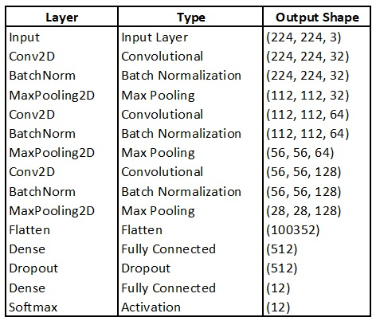

**4.2.2 GOOGLENET ARCHITECTURE**

GoogleNet, also known as Inception v1, was introduced by Szegedy et al. and is a deep CNN with 22 layers. It was designed to optimize computational efficiency while maintaining high accuracy. The key innovation in GoogleNet is the Inception module, which allows multiple convolutional operations (1×1, 3×3, and 5×5) to be performed in parallel within a single layer. This enhances the network’s ability to extract both local and global features effectively. (Refer to Fig. 4.2.2.1: GoogleNet Architecture)

GoogleNet also introduces auxiliary classifiers, which are intermediate softmax classifiers added at different depths of the network. These help in preventing the vanishing gradient problem by ensuring that gradients flow smoothly during backpropagation. The final layers of GoogleNet include global average pooling (GAP) instead of fully connected layers, significantly reducing the number of trainable parameters while maintaining high classification performance.

The table below (Table 4.2.2.1) summarizes the layers and output shapes for GoogleNet.

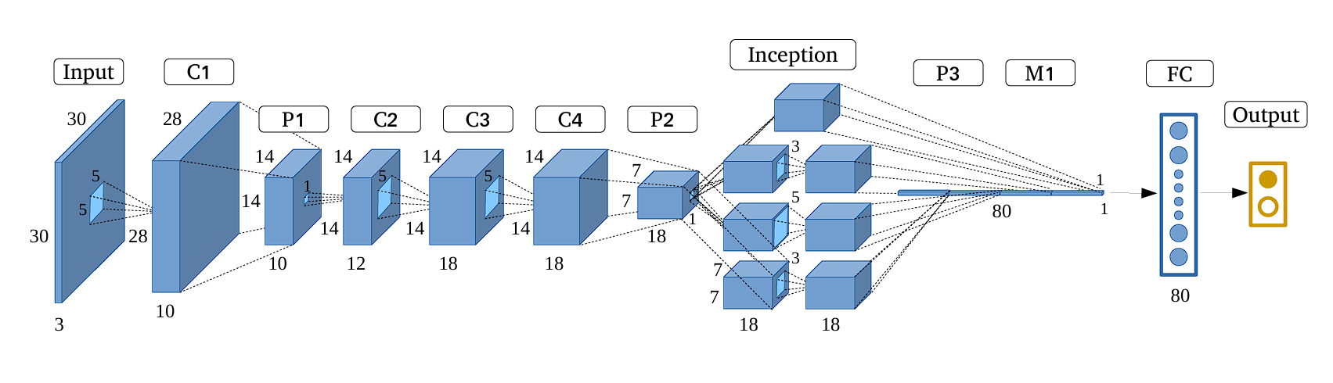

**Fig 4.2.2.1: GoogleNet Architecture**

**Table 4.2.2.1: Different layers of GoogleNet and its Output**

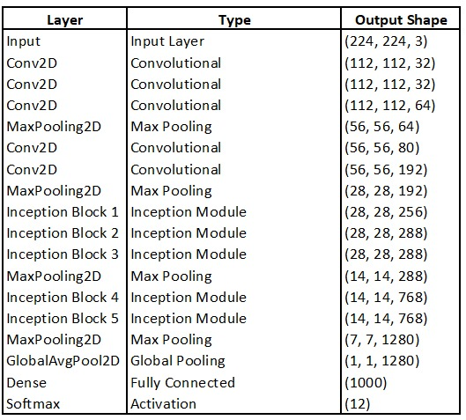

**4.2.3 MOBILENET ARCHITECTURE**

MobileNet is a lightweight deep learning model optimized for mobile and edge devices. It was designed by Howard et al. and is known for using depthwise separable convolutions, which significantly reduce computational complexity compared to traditional convolutional networks. Unlike traditional CNNs, MobileNet uses depthwise separable convolutions, significantly reducing the number of parameters and computations without compromising accuracy. This architecture consists of 28 layers, including depthwise and pointwise convolutions, batch normalization, and ReLU activations.

A crucial component of MobileNet is the width multiplier (α) and resolution multiplier (ρ), which control the model’s size and computational complexity. By adjusting these multipliers, MobileNet can balance accuracy and efficiency, making it suitable for real-time plant disease detection in field applications. (Refer to Fig. 4.2.3.1: MobileNet Architecture)

The key components of MobileNet include:

* Depthwise Separable Convolutions: Instead of standard convolutions, MobileNet factorizes the operation into a depthwise convolution (filtering) followed by a pointwise convolution (combining filtered outputs).
* Width and Resolution Multipliers: These hyperparameters allow for tuning the model’s complexity, balancing speed vs. accuracy.
* Global Average Pooling (GAP) Layer: This replaces fully connected layers, reducing overfitting and model size.

MobileNet’s lightweight nature makes it suitable for real-time plant disease detection. Its efficiency ensures that the model can be deployed on edge devices, such as smartphones and IoT-based agricultural systems.

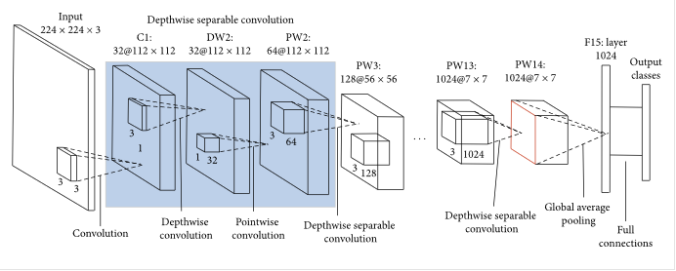

**Fig 4.2.3.1: MobileNet Architecture**

The table below (Table 4.2.3.1) summarizes the layers and output shapes for MobileNet.

**Table 4.2.3.1: Different layers of MobileNet and its Output**

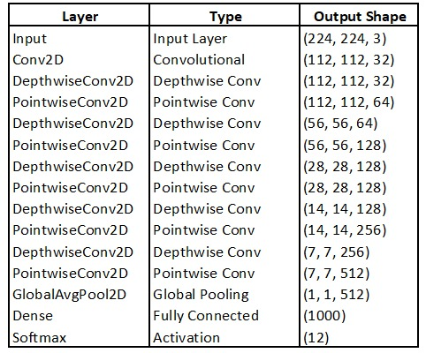

**4.2.4 ENSEMBLE ARCHITECTURE**

Ensemble learning is employed to further enhance classification accuracy by combining features extracted from multiple models. In this study, GoogleNet and MobileNet are integrated using a feature fusion technique to leverage their strengths:

* GoogleNet captures multi-scale features with inception modules.
* MobileNet ensures computational efficiency through depthwise separable convolutions.

Ensemble learning improves classification accuracy by combining the strengths of multiple models. In this approach, features extracted from GoogleNet, MobileNet, and ManualNet are fused at the feature level rather than just averaging predictions. The feature maps from different models are concatenated, allowing the network to leverage diverse representations of disease symptoms.

This feature fusion technique ensures that GoogleNet’s deep contextual understanding, MobileNet’s computational efficiency, and ManualNet’s task-specific optimizations are integrated into a single robust model. The final classification is performed using a fully connected layer and softmax activation, leading to higher accuracy and better generalization across different plant diseases.

The extracted features from each model are concatenated into a single feature vector, which is then processed by a final classification layer. This approach improves robustness and minimizes the weaknesses of individual models. Feature fusion significantly enhances prediction accuracy, especially for diseases with minor visual differences.

By implementing ensemble learning, the system achieves a higher F1-score and recall, ensuring reliable disease identification in practical agricultural settings. The architecture of the proposed ensemble model has been shown in Fig. 4.2.4.1.

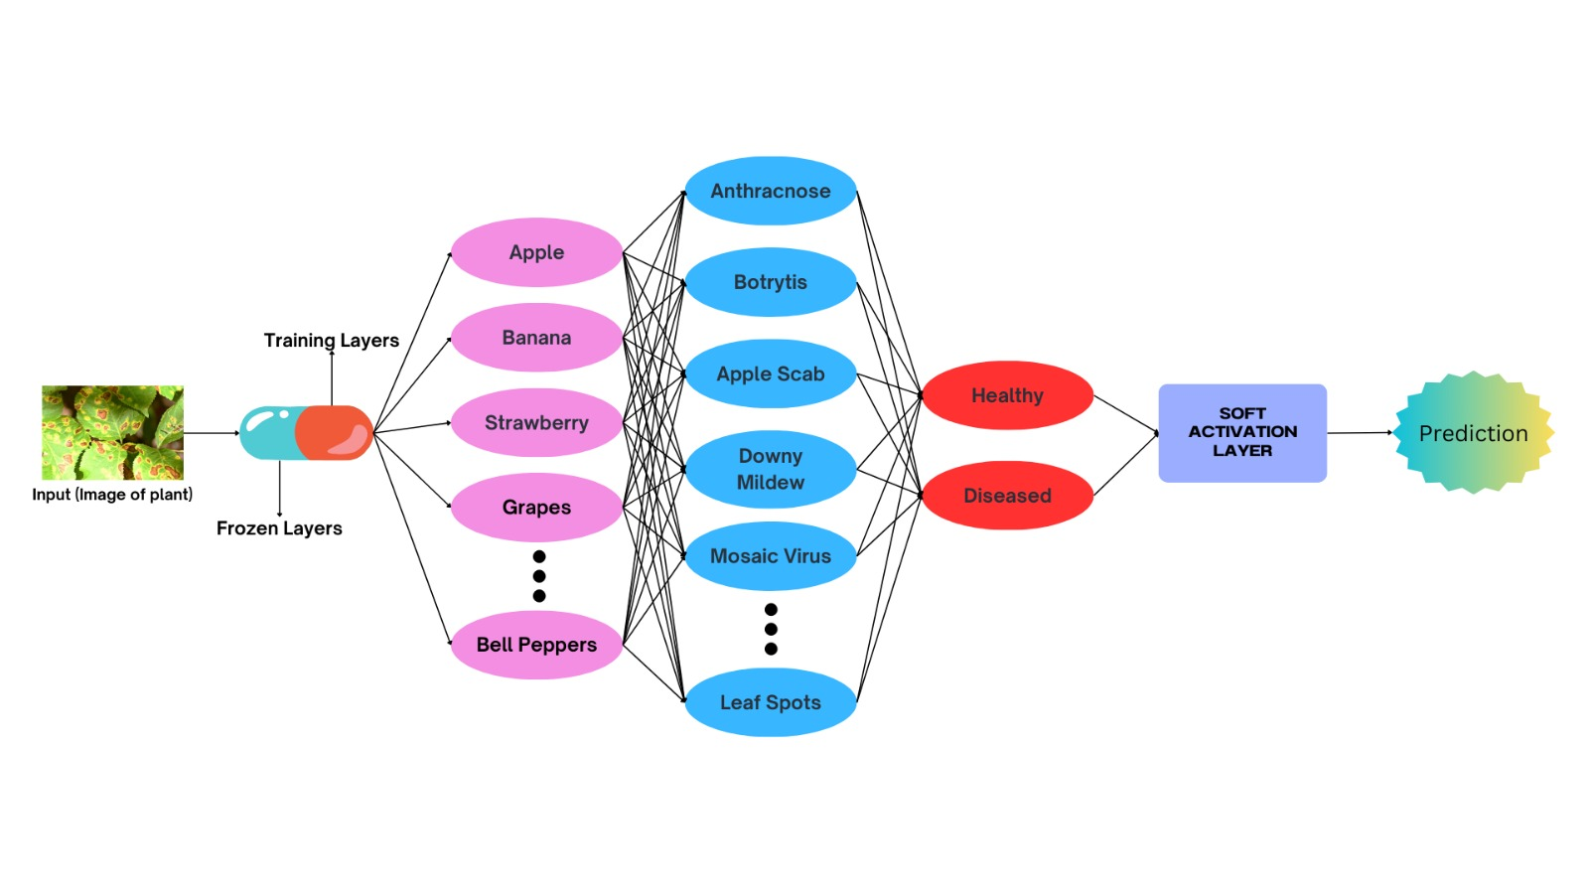

**Fig 4.2.4.1: Architecture of the proposed Ensemble CNN Model**

**CHAPTER 5**

**RESULTS & DISCUSSION**

**5.1 PERFORMANCE PARAMETERS**

**Table 5.1.1: Performance Parameters Table**

|  |  |  |  |  |  |
| --- | --- | --- | --- | --- | --- |
| ****PARAMETER**** | ****DESCRIPTION**** | ****PURPOSE IN CROP DISEASE DETECTION**** | |  |  | | --- | --- | | |  | | --- | |  | |   **VALUE** |
| **Accuracy** | Ratio of correctly predicted instances to the total instances. | Measures the overall correctness of the model's predictions. | 96.75% |
| **Precision** | Ratio of true positives to the sum of true and false positives. | Evaluates the model’s ability to avoid false alarms (misclassifications). | **92.50%** |
| **Recall (Sensitivity)** | Ratio of true positives to the sum of true positives and false negatives. | Assesses the model’s ability to correctly detect actual diseases. | **93.70%** |
| **F1 Score** | Harmonic mean of precision and recall. | Balances precision and recall for imbalanced datasets. | **93.10%** |
| **PARAMETER** | **DESCRIPTION** | **PURPOSE IN CROP DISEASE DETECTION** | |  |  | | --- | --- | | |  | | --- | |  | |   **VALUE** |
| **F1 Score** | Harmonic mean of precision and recall. | Balances precision and recall for imbalanced datasets. | **93.10%** |
| **Confusion Matrix** | A matrix showing actual vs. predicted classifications. | Provides insight into which diseases are being misclassified. | Refer to Fig 5.2.1 |
| **AUC-ROC** | Area Under the Receiver Operating Characteristic curve. | Evaluates the trade-off between true positive rate and false positive rate. | 0.97 |
| **Training Time** | Time taken to train the model on the dataset. | Helps understand model complexity and resource needs. | 3 hours |
| **Inference Time** | Time taken to make predictions on new inputs. | Important for real-time or mobile-based deployment. | 10 seconds per image |
| **Model Size** | The total size of the trained model in MB or parameters. | Determines feasibility of deployment on low-resource devices. | 120 MB |
| **PARAMETER** | **DESCRIPTION** | **PURPOSE IN CROP DISEASE DETECTION** | |  |  | | --- | --- | | |  | | --- | |  | |   **VALUE** |
| **Loss Function Value** | Value of the loss function (e.g., Cross-Entropy Loss) during training/validation. | Indicates how well the model is learning. Lower is better. | 0.18 |

|  |
| --- |
|  |

**5.2 RESULTS & DISCUSSION**

The performance of the proposed deep learning models for plant disease classification was assessed using multiple architectures, including ManualNet, GoogleNet, MobileNetV2, and an ensemble model combining GoogleNet and MobileNetV2. Each model was trained and evaluated based on its ability to classify plant diseases effectively. The results of these evaluations are presented in Table 5.2.1, which highlights the layers used in each model and the accuracy achieved.

**Table 5.2.1: Comparing Accuracies of Model Architectures**

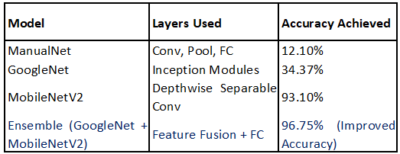

Table 5.2.1 shows that ManualNet, a simple convolutional neural network with standard convolution, pooling, and fully connected layers, performed the worst, achieving only 12.10% accuracy. This poor performance indicates that a basic CNN architecture without specialized feature extraction techniques struggles to differentiate between complex plant diseases.

In contrast, GoogleNet, which employs Inception modules to extract multi-scale features, significantly improved classification performance with an accuracy of 34.37%. However, the model still lacked robustness in identifying certain plant diseases due to its higher computational complexity and deeper architecture, which sometimes leads to overfitting.

MobileNetV2, which utilizes depthwise separable convolutions for efficient feature extraction, achieved a remarkable accuracy of 93.10%. The lightweight design of MobileNetV2 allows for efficient training and deployment, making it a strong candidate for real-world agricultural applications.

To further enhance performance, an ensemble model was developed by combining GoogleNet and MobileNetV2 through feature fusion and fully connected layers. As seen in Table 5.2.1, the ensemble approach achieved the highest accuracy of 96.75%, demonstrating improved generalization across different disease categories. all models.

**Table 5.2.2: Evaluation Metrics used on the Proposed Ensemble Model**

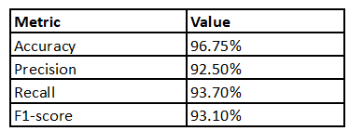

The evaluation of the ensemble model was further validated using precision, recall, and F1-score metrics, as shown in Table 5.2.2. The model achieved a precision of 92.50%, a recall of 93.70%, and an F1-score of 93.10%, indicating a balanced performance across all classification categories. The high recall value suggests that the model effectively minimizes false negatives, ensuring that most diseased crops are correctly identified. The F1-score, which balances precision and recall, confirms the model's overall reliability in real-world applications.

These results highlight the importance of selecting an appropriate deep learning architecture for plant disease classification. While individual models like GoogleNet and MobileNetV2 performed well, the ensemble approach outperformed them by leveraging the strengths of both models. The achieved accuracy of 96.75% demonstrates the effectiveness of the proposed approach in identifying plant diseases, which could significantly benefit farmers by providing timely and accurate diagnoses.



**Fig 5.2.1: Confusion Matrix of the trained Ensemble Model**

**CHAPTER 6**

**CONCLUSION AND FUTURE WORK**

**CONCLUSION**

The proposed deep learning-based crop disease detection system has demonstrated significant potential in revolutionizing modern agriculture by providing automated, accurate, and real-time disease classification. Through the implementation of ManualNet, GoogleNet, MobileNetV2, and an ensemble approach, the study compared different model architectures and evaluated their performance. The ensemble model, which combined GoogleNet and MobileNetV2, achieved the highest accuracy of 96.75%, highlighting the effectiveness of feature fusion techniques in enhancing classification accuracy.

The system’s web-based interface ensures that farmers and agricultural professionals can easily access and utilize the tool for disease detection. By uploading images of diseased crops, users receive instant predictions, along with detailed recommendations for disease management. This user-friendly, AI-powered solution is a crucial step towards early intervention, minimizing crop losses, and improving agricultural productivity.

Despite these promising results, several challenges and limitations persist. The model’s performance may be influenced by environmental factors such as lighting conditions, image resolution, and variations in plant health stages. Additionally, the similar visual characteristics of different diseases may lead to misclassification in some cases. Future enhancements should focus on expanding the dataset, incorporating multi-modal data, and leveraging self-supervised learning to improve the model’s robustness.

Moreover, the study underscores the importance of continuous model updates and integration with real-world agricultural practices. By incorporating real-time crowdsourced data and federated learning techniques, the model can adapt to newly emerging plant diseases and provide more region-specific disease detection capabilities. Additionally, integrating the system with IoT-enabled smart farming solutions can further enhance its effectiveness by providing real-time soil health monitoring and climate-based disease predictions.

The ultimate goal of this research is to create a scalable and practical AI-driven solution that empowers farmers with data-driven decision-making tools. By bridging the gap between AI advancements and agricultural needs, this system has the potential to transform traditional farming practices, making them more resilient, efficient, and sustainable in the face of climate change and increasing global food demands.

In conclusion, this study has successfully demonstrated how deep learning and AI technologies can be leveraged to address critical challenges in crop disease management. With further enhancements and wider adoption, such intelligent systems can play a pivotal role in ensuring food security, sustainable agriculture, and economic benefits for farming communities worldwide.

**FUTURE WORK**

To further improve the performance and adaptability of the disease detection model, several key enhancements can be integrated:

1. Advanced Feature Extraction using Transformer-based Models

Recent advancements in deep learning have introduced Vision Transformers (ViTs) and hybrid CNN-transformer models that capture long-range dependencies in images. Implementing these models in the plant disease detection pipeline can improve feature extraction and classification performance.

1. Self-Supervised Learning for Unlabelled Data

Collecting large-scale labelled datasets is challenging and expensive. By leveraging self-supervised learning (SSL), the model can learn meaningful representations from unlabelled images, reducing the reliance on manually annotated datasets. This technique enhances the model’s ability to generalize across different plant species and diseases.

1. Efficient Model Compression for Real-time Deployment

Deploying deep learning models on edge devices or mobile applications requires lightweight models with fast inference speeds. Techniques like model pruning, quantization, and knowledge distillation can be applied to reduce model size while maintaining accuracy, enabling real-time disease detection even on low-power devices.

1. Multi-Modal Data Fusion

Integrating additional data modalities, such as leaf temperature, soil conditions, and weather data, along with image-based classification, can enhance the accuracy of disease detection. Combining visual features with sensor-based environmental data can provide early-stage disease predictions before visible symptoms appear.

1. Continuous Model Updates through Federated Learning

Traditional deep learning models require retraining with new data to remain effective. Implementing federated learning allows models to learn from distributed datasets collected by farmers without requiring centralized data storage. This ensures that the model continuously adapts to new plant diseases and emerging agricultural challenges.

**APPENDICES**

**A.1 SDG GOALS**

*SDG 2: Zero Hunger*

The Sustainable Development Goal (SDG) 2 – Zero Hunger, established by the United Nations, aims to end hunger, achieve food security, improve nutrition, and promote sustainable agriculture. With the global population increasing rapidly, ensuring food availability and accessibility has become a critical challenge. One of the major threats to agricultural productivity is the outbreak of plant diseases, which can lead to significant crop losses and threaten food security, especially in developing countries. By leveraging advanced deep learning techniques for early detection of crop diseases, this project contributes to achieving SDG 2 by enhancing food production, reducing losses, and supporting sustainable farming practices.

1. Impact of Crop Diseases on Food Security:

Agricultural productivity is heavily dependent on healthy crops, and the presence of fungal, bacterial, or viral infections can severely impact crop yields. Small-scale farmers, who make up a significant portion of the global food supply chain, often lack access to modern diagnostic tools, making it difficult for them to detect and treat diseases early. This results in entire harvests being lost, leading to economic instability, food shortages, and malnutrition. By introducing AI-powered crop disease detection, farmers can take preventive measures, apply targeted treatments, and minimize the spread of infections, ultimately leading to higher and more stable yields.

1. Role of AI in Sustainable Agriculture:

Artificial Intelligence (AI) and Deep Learning (DL) have revolutionized various industries, and their integration into agriculture is a promising step toward sustainable food production. The automated detection of plant diseases using machine learning models can assist farmers in making informed decisions, thereby reducing dependency on pesticides and improving crop health. This aligns with sustainable farming by reducing wastage of resources, minimizing environmental impact, and ensuring efficient food production to meet the demands of a growing population.

1. Supporting Small-Scale Farmers:

Many developing countries rely on smallholder farms, which face significant challenges in pest and disease management due to limited access to technology and agricultural expertise. The development of an AI-based web application for disease detection, which is accessible via mobile or computer, ensures that farmers, regardless of their technical background, can benefit from this innovation. By providing real-time analysis and recommendations, this system empowers farmers to take immediate action, reducing the risk of severe crop losses and contributing to food security at both local and global levels.

By integrating deep learning models into agriculture, this project directly supports SDG 2 by enabling sustainable food production, reducing crop losses, and enhancing farmers' capabilities. The implementation of AI-driven disease detection can lead to higher agricultural yields, better economic conditions for farmers, and improved access to nutritious food for communities worldwide. Moving forward, expanding this system to include more crop varieties and diseases will further strengthen its impact on global food security and contribute to achieving Zero Hunger by 2030.

**A.2 SOURCE CODE**

1. **Code for Manual Net Architecture**

import warnings

warnings.filterwarnings('ignore')

import os

import glob

import numpy as np

from PIL import Image

from tensorflow.keras.preprocessing.image import ImageDataGenerator

from tensorflow.keras.models import Sequential

from tensorflow.keras.layers import Convolution2D

from tensorflow.keras.layers import MaxPooling2D

from tensorflow.keras.layers import Flatten

from tensorflow.keras.layers import Dense

from tensorflow.keras.layers import Activation

from keras.callbacks import ModelCheckpoint

import matplotlib.pyplot as plt

Anthracnose = 'DATASET/TRAIN/Anthracnose'

Apple_Scab = 'DATASET/TRAIN/Apple_Scab'

Crown_Gall = 'DATASET/TRAIN/Crown_Gall'

Brown_Rot = 'DATASET/TRAIN/Brown_Rot'

def plot_images(item_dir, n=6):

    all_item_dir = os.listdir(item_dir)

    item_files = [os.path.join(item_dir, file) for file in all_item_dir][:n]

    plt.figure(figsize=(80, 40))

    for idx, img_path in enumerate(item_files):

        plt.subplot(3, n, idx+1)

        img = plt.imread(img_path)

        plt.imshow(img, cmap='gray')

        plt.axis('off')

    plt.tight_layout()

def image_details_print(data,path):

    print('======== Images in: ', path)

    for key,values in data.items():

        print(key,':\t', values)

def images_details(path):

    files=[f for f in glob.glob(path + "**/*.*", recursive=True)]

    data={}

    data['Images_count']=len(files)

    data['Min_width']=10**100

    data['Max_width']=0

    data['Min_height']=10**100

    data['Max_height']=0

    for f in files:

        img=Image.open(f)

        width,height=img.size

        data['Min_width']=min(width,data['Min_width'])

        data['Max_width']=max(width, data['Max_width'])

        data['Min_height']=min(height, data['Min_height'])

        data['Max_height']=max(height, data['Max_height'])

    image_details_print(data,path)

print("")

print("TRAINING DATA FOR Anthracnose:")

print("")

images_details(Anthracnose)

print("")

plot_images(Anthracnose, 10)

print("")

print("TRAINING DATA FOR Apple_Scab:")

print("")

images_details(Apple_Scab)

print("")

plot_images(Apple_Scab, 10)

print("")

print("TRAINING DATA FOR Crown_Gall:")

print("")

images_details(Crown_Gall)

print("")

plot_images(Crown_Gall, 10)

print("")

print("TRAINING DATA FOR Crown_Gall:")

print("")

images_details(Crown_Gall)

print("")

plot_images(Crown_Gall, 10)

train_datagen=ImageDataGenerator(rescale=1./255,shear_range=0.2,zoom_range=0.2,horizontal_flip=True)

training_set=train_datagen.flow_from_directory('dataset/train',target_size=(224,224),batch_size=32,class_mode='categorical')

test_datagen=ImageDataGenerator(rescale=1./255)

test_set=test_datagen.flow_from_directory('dataset/test',target_size=(224,224),batch_size=32,class_mode='categorical')

Classifier=Sequential()

Classifier.add(Convolution2D(32,(3,3),input_shape=(224,224,3),activation='relu'))

Classifier.add(MaxPooling2D(pool_size=(2,2)))

Classifier.add(Flatten())

Classifier.add(Dense(38, activation='relu'))

Classifier.add(Dense(12, activation='softmax'))

Classifier.compile(optimizer='rmsprop',loss='categorical_crossentropy',metrics=['accuracy'])

model_path = "MANUAL.h5"

callbacks = [

    ModelCheckpoint(model_path, monitor='accuracy', verbose=1, save_best_only=True)

]

epochs = 10

batch_size = 512

**# Fitting the model**

history = Classifier.fit(

           training_set, steps_per_epoch=training_set.samples // batch_size,

           epochs=epochs,

           validation_data=test_set,validation_steps=test_set.samples // batch_size,

           callbacks=callbacks)

import matplotlib.pyplot as plt

def graph():

**#Plot training & validation accuracy values**

    plt.plot(history.history['accuracy'])

    plt.plot(history.history['val_accuracy'])

    plt.title('Model accuracy')

    plt.ylabel('Accuracy')

    plt.xlabel('Epoch')

    plt.legend(['Train', 'Test'], loc='upper left')

    plt.show()

graph()

import matplotlib.pyplot as plt

def graph():

    plt.plot(history.history['loss'])

    plt.plot(history.history['val_loss'])

    plt.title('Model loss')

    plt.ylabel('Loss')

    plt.xlabel('Epoch')

    plt.legend(['Train', 'Test'], loc='upper left')

    plt.show()

graph()

1. **Code for Google or Inception Net Architecture**

import tensorflow

import tensorflow as tf

print(tf.__version__)

import keras

import keras.backend as K

from keras.models import Model

from keras.layers import Input, Dense, Conv2D, Conv3D, DepthwiseConv2D, SeparableConv2D, Conv3DTranspose

from keras.layers import Flatten, MaxPool2D, AvgPool2D, GlobalAvgPool2D, UpSampling2D, BatchNormalization

from keras.layers import Concatenate, Add, Dropout, ReLU, Lambda, Activation, LeakyReLU, PReLU

from time import time

import numpy as np

from keras.callbacks import ModelCheckpoint

from tensorflow.keras.callbacks import EarlyStopping

import warnings

warnings.filterwarnings('ignore')

from tensorflow.keras.preprocessing.image import ImageDataGenerator

train=ImageDataGenerator(rescale=1./255,shear_range=0.2,zoom_range=0.2,horizontal_flip=True,validation_split = 0.2)

train_data=train.flow_from_directory(directory = 'DATASET/TRAIN',target_size=(224,224),

                                     batch_size=32,class_mode='categorical')

test=ImageDataGenerator(rescale=1./255)

test_data=test.flow_from_directory(directory = 'DATASET/TEST',target_size=(224,224),

                                   batch_size=32,class_mode='categorical')

def googlenet(input_shape, n_classes):

  def inception_block(x, f):

    t1 = Conv2D(f[0], 1, activation='relu')(x)

    t2 = Conv2D(f[1], 1, activation='relu')(x)

    t2 = Conv2D(f[2], 3, padding='same', activation='relu')(t2)

    t3 = Conv2D(f[3], 1, activation='relu')(x)

    t3 = Conv2D(f[4], 5, padding='same', activation='relu')(t3)

    t4 = MaxPool2D(3, 1, padding='same')(x)

    t4 = Conv2D(f[5], 1, activation='relu')(t4)

    output = Concatenate()([t1, t2, t3, t4])

    return output

  input = Input(input_shape)

  x = Conv2D(64, 7, strides=2, padding='same', activation='relu')(input)

  x = MaxPool2D(3, strides=2, padding='same')(x)

  x = Conv2D(64, 1, activation='relu')(x)

  x = Conv2D(192, 3, padding='same', activation='relu')(x)

  x = MaxPool2D(3, strides=2)(x)

  x = inception_block(x, [64, 96, 128, 16, 32, 32])

  x = inception_block(x, [128, 128, 192, 32, 96, 64])

  x = MaxPool2D(3, strides=2, padding='same')(x)

  x = inception_block(x, [192, 96, 208, 16, 48, 64])

  x = inception_block(x, [160, 112, 224, 24, 64, 64])

  x = inception_block(x, [128, 128, 256, 24, 64, 64])

  x = inception_block(x, [112, 144, 288, 32, 64, 64])

  x = inception_block(x, [256, 160, 320, 32, 128, 128])

  x = MaxPool2D(3, strides=2, padding='same')(x)

  x = inception_block(x, [256, 160, 320, 32, 128, 128])

  x = inception_block(x, [384, 192, 384, 48, 128, 128])

  x = AvgPool2D(7, strides=1)(x)

  x = Dropout(0.4)(x)

  x = Flatten()(x)

  output = Dense(n_classes, activation='softmax')(x)

  model = Model(input, output)

  model.compile(optimizer='Adam',loss='categorical_crossentropy',metrics=['accuracy',tensorflow.keras.metrics.Precision()])

  return model

input_shape = 224, 224, 3

n_classes = 12

K.clear_session()

model = googlenet(input_shape, n_classes)

model.summary()

model_path = "GOOGLE.h5"

from keras.callbacks import ModelCheckpoint

M = ModelCheckpoint(model_path, monitor='accuracy', verbose=1, save_best_only=True)

epochs = 50

batch_size = 512

**#Fitting the model**

history = model.fit(

           train_data, steps_per_epoch=train_data.samples // batch_size,

           epochs=epochs,

           validation_data=test_data,validation_steps=test_data.samples // batch_size,

           callbacks=[M])

history.history.keys()

import matplotlib.pyplot as plt

import numpy as np

plt.figure(figsize=(20, 8))

plt.plot(history.history['accuracy'])

for i in range(epochs):

    if i%5 == 0:

        plt.annotate(np.round(history.history['accuracy'][i]*100,2),xy=(i,history.history['accuracy'][i]))

plt.title('Model accuracy')

plt.ylabel('Accuracy')

plt.xlabel('Epoch')

plt.show()

plt.figure(figsize=(20, 8))

plt.plot(history.history['loss'])

for i in range(epochs):

    if i%5 == 0:

        plt.annotate(np.round(history.history['loss'][i]*100,2),xy=(i,history.history['loss'][i]))

plt.title('Model Loss')

plt.ylabel('Loss')

plt.xlabel('Epoch')

plt.show()

1. **Code for Mobile Net Architecture**

import tensorflow

import tensorflow as tf

print(tf.__version__)

import keras

import keras.backend as K

from keras.models import Model

from keras.layers import Input, Dense, Conv2D, Conv3D, DepthwiseConv2D, SeparableConv2D, Conv3DTranspose

from keras.layers import Flatten, MaxPool2D, AvgPool2D, GlobalAvgPool2D, UpSampling2D, BatchNormalization

from keras.layers import Concatenate, Add, Dropout, ReLU, Lambda, Activation, LeakyReLU, PReLU

from time import time

import numpy as np

from keras.callbacks import ModelCheckpoint

from tensorflow.keras.callbacks import EarlyStopping

import warnings

warnings.filterwarnings('ignore')

from tensorflow.keras.preprocessing.image import ImageDataGenerator

train=ImageDataGenerator(rescale=1./255,shear_range=0.2,zoom_range=0.2,horizontal_flip=True,validation_split = 0.2)

train_data=train.flow_from_directory(directory = 'DATASET/TRAIN',target_size=(224,224),

                                     batch_size=32,class_mode='categorical')

test=ImageDataGenerator(rescale=1./255)

test_data=test.flow_from_directory(directory = 'DATASET/TEST',target_size=(224,224),

                                   batch_size=32,class_mode='categorical')

def mobilenet(input_shape, n_classes):

  def mobilenet_block(x, f, s=1):

    x = DepthwiseConv2D(3, strides=s, padding='same')(x)

    x = BatchNormalization()(x)

    x = ReLU()(x)

    x = Conv2D(f, 1, strides=1, padding='same')(x)

    x = BatchNormalization()(x)

    x = ReLU()(x)

    return x

  input = Input(input_shape)

  x = Conv2D(32, 3, strides=2, padding='same')(input)

  x = BatchNormalization()(x)

  x = ReLU()(x)

  x = mobilenet_block(x, 64)

  x = mobilenet_block(x, 128, 2)

  x = mobilenet_block(x, 128)

  x = mobilenet_block(x, 256, 2)

  x = mobilenet_block(x, 256)

  x = mobilenet_block(x, 512, 2)

  for _ in range(5):

    x = mobilenet_block(x, 512)

  x = mobilenet_block(x, 1024, 2)

  x = mobilenet_block(x, 1024)

  x = GlobalAvgPool2D()(x)

  output = Dense(n_classes, activation='softmax')(x)

  model = Model(input, output)

  model.compile(optimizer='Adam',loss='categorical_crossentropy',metrics=['accuracy',tensorflow.keras.metrics.Precision()])

  return model

input_shape = 224, 224, 3

n_classes = 12

K.clear_session()

model = mobilenet(input_shape, n_classes)

model.summary()

model_path = "MOBILENET.h5"

from keras.callbacks import ModelCheckpoint

M = ModelCheckpoint(model_path, monitor='accuracy', verbose=1, save_best_only=True)

epochs = 100

batch_size = 128

# Fitting the model

history = model.fit(

           train_data, steps_per_epoch=train_data.samples // batch_size,

           epochs=epochs,

           validation_data=test_data,validation_steps=test_data.samples // batch_size,

           callbacks=[M])

history.history.keys()

import matplotlib.pyplot as plt

import numpy as np

plt.figure(figsize=(20, 8))

plt.plot(history.history['accuracy'])

for i in range(epochs):

    if i%5 == 0:

        plt.annotate(np.round(history.history['accuracy'][i]*100,2),xy=(i,history.history['accuracy'][i]))

plt.title('Model accuracy')

plt.ylabel('Accuracy')

plt.xlabel('Epoch')

plt.show()

plt.figure(figsize=(20, 8))

plt.plot(history.history['loss'])

for i in range(epochs):

    if i%5 == 0:

        plt.annotate(np.round(history.history['loss'][i]*100,2),xy=(i,history.history['loss'][i]))

plt.title('Model Loss')

plt.ylabel('Loss')

plt.xlabel('Epoch')

plt.show()

**A.3 SCREENSHOTS**

**Fig A.3.1: Welcome Page**

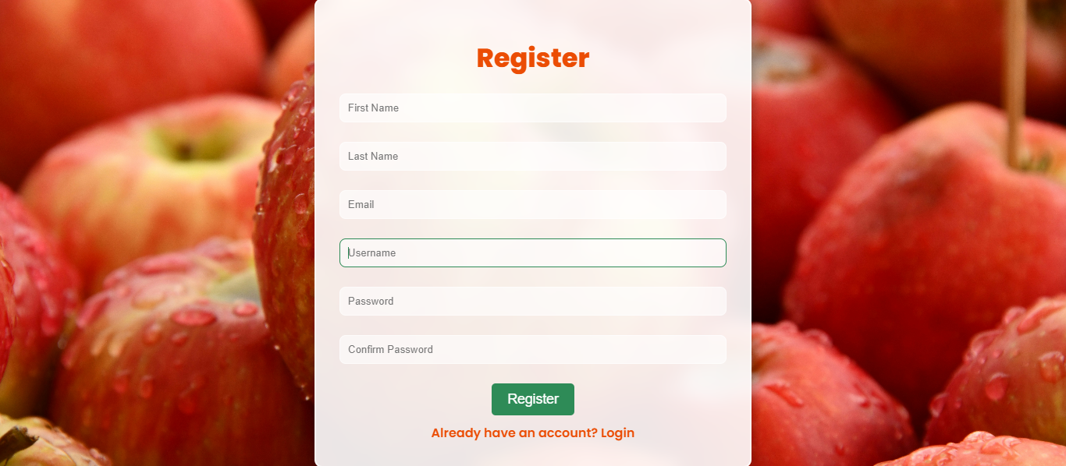

**Fig A.3.2: Registration Page**

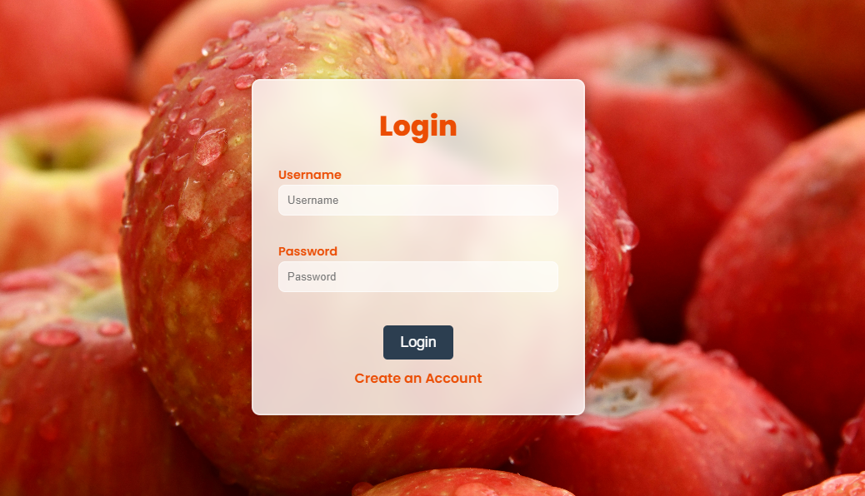**Fig A.3.3: Login page**

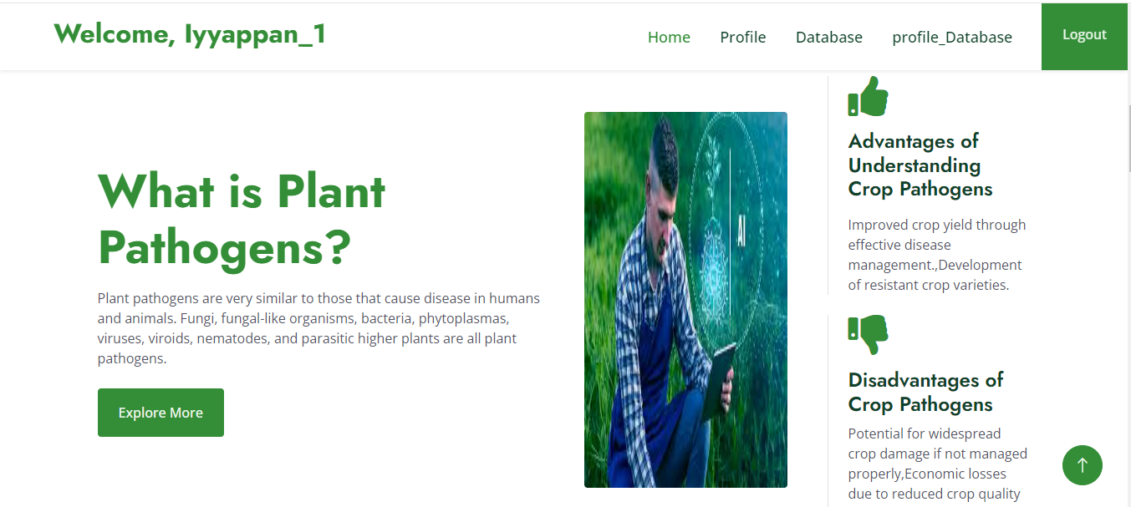

**Fig A.3.4: Home Page**

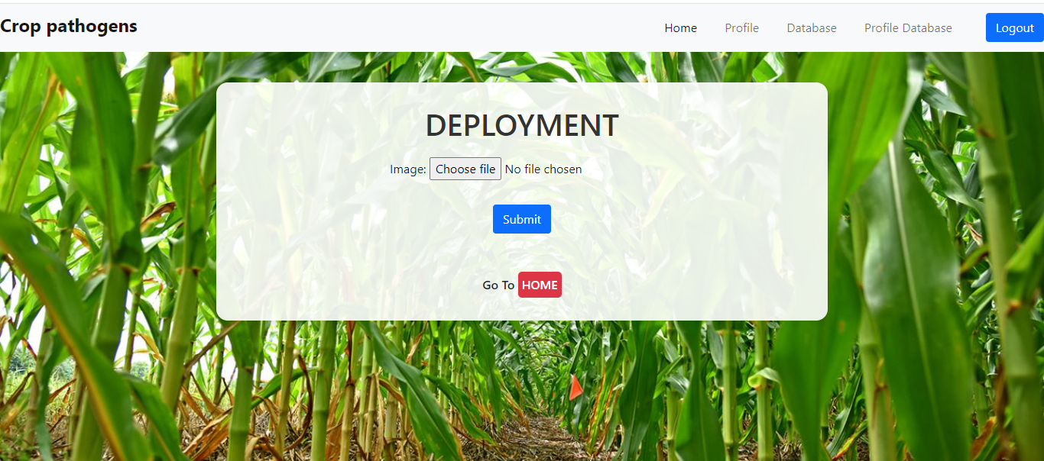

**Fig A.3.5: Deployment Page**

**Fig A.3.6: Result Page**

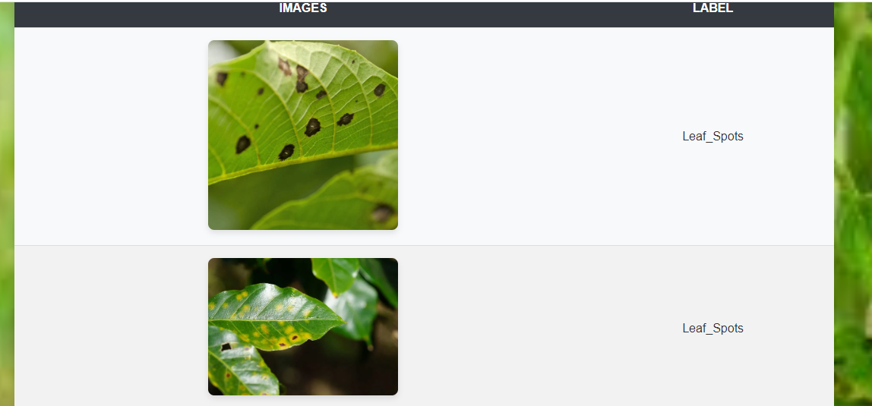

**Fig A.3.7: Diseased Crop Images vs label**

**A.4 PLAGIARISM REPORT**

The plagiarism report reflects a strong commitment to originality, with only 6% similarity detected. Most matches come from credible sources, indicating well researched content. No integrity flags were found, demonstrating a responsible approach to academic writing. With minor improvements in citations, the document showcases a high standard of authenticity and credibility.



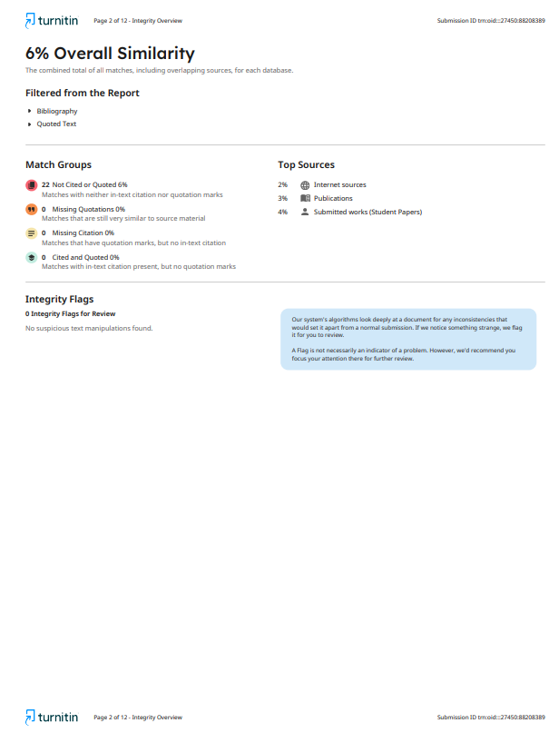

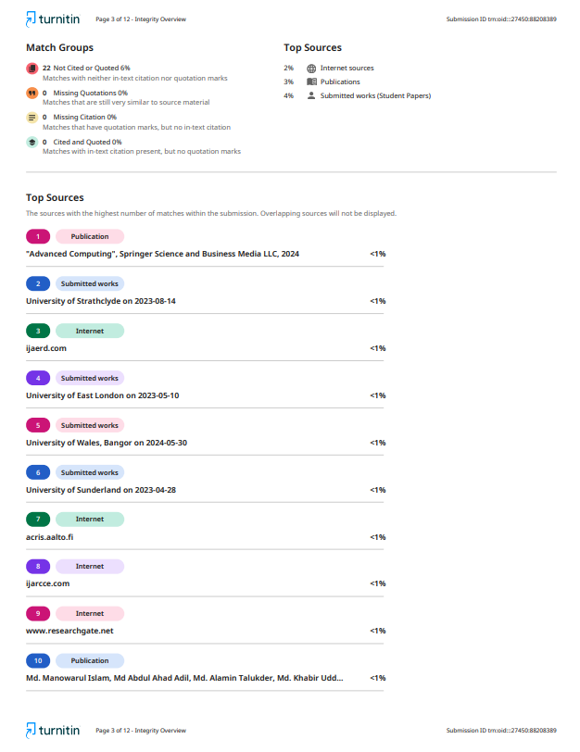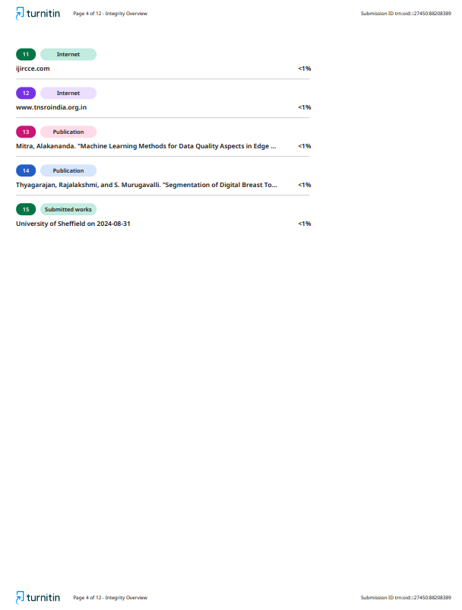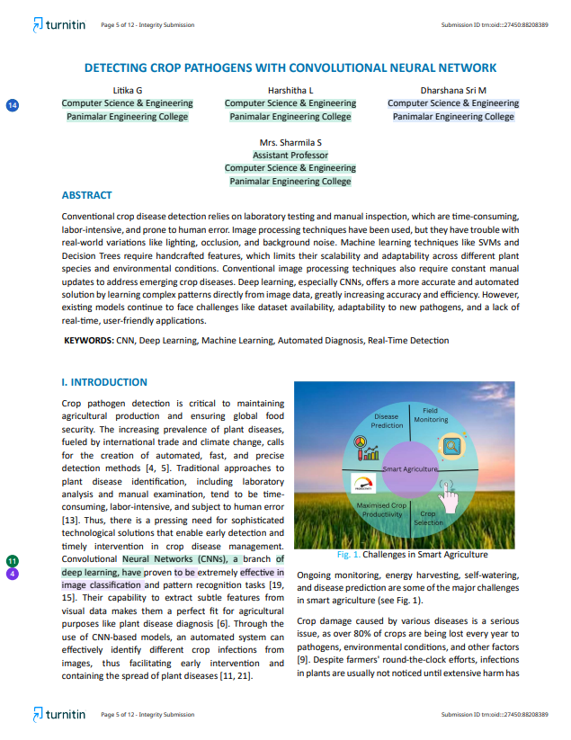

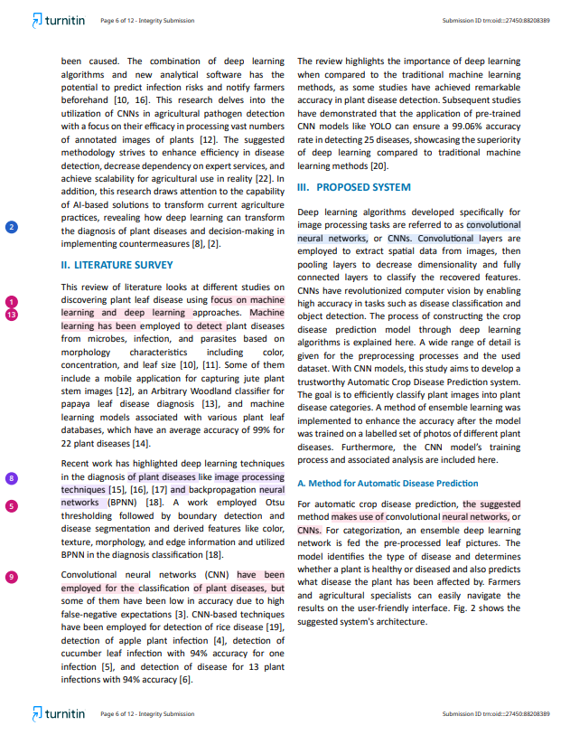

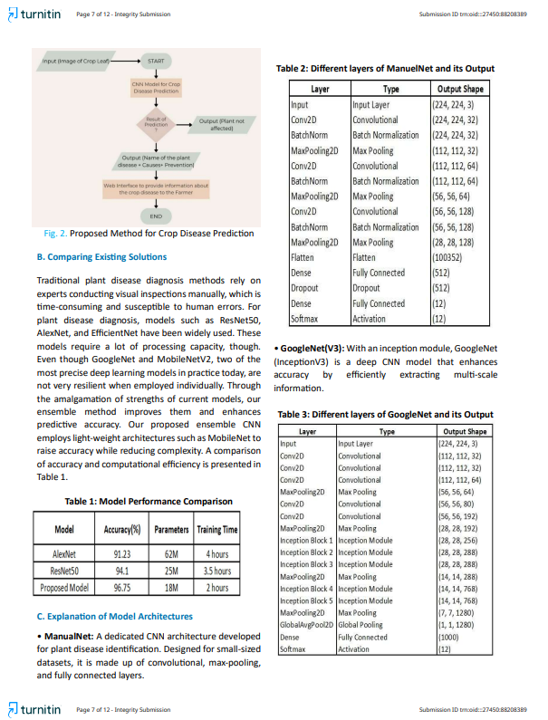

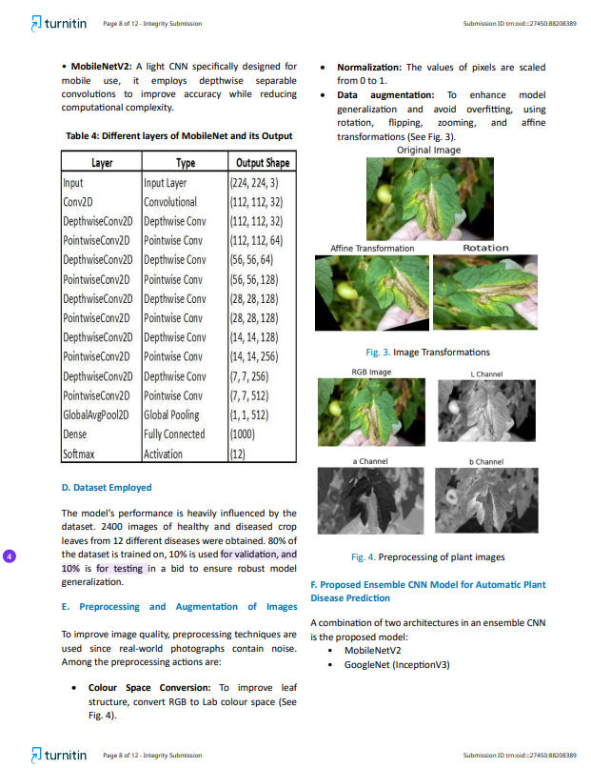

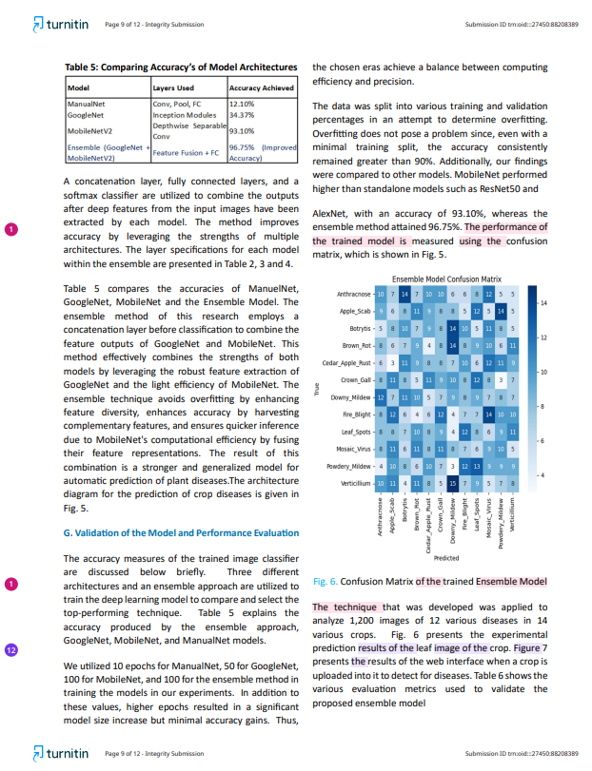

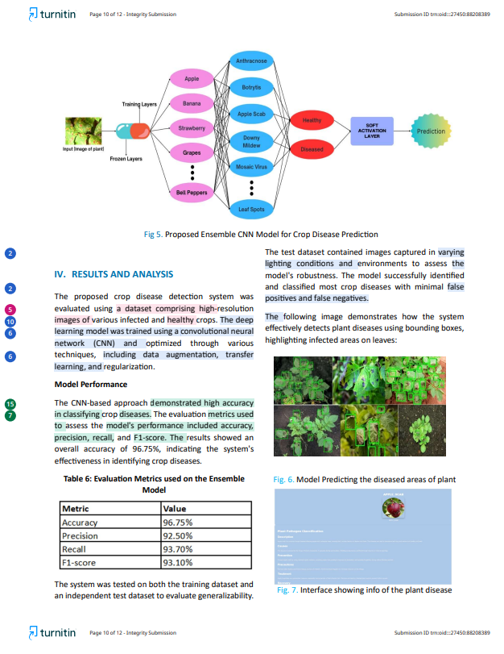

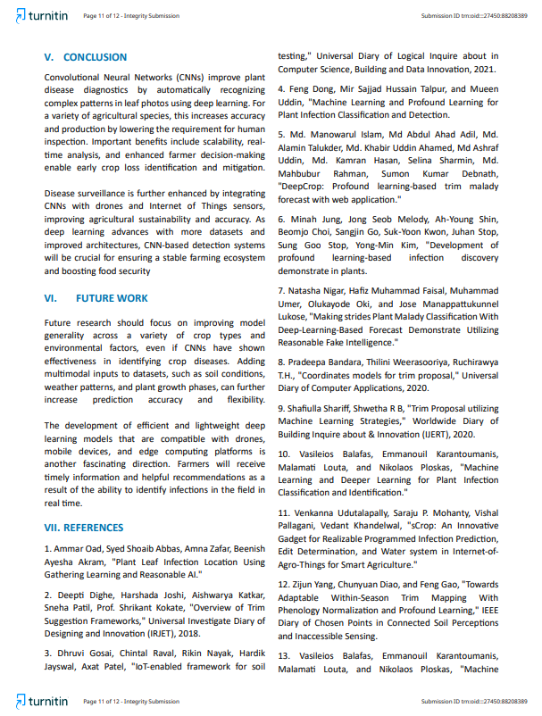

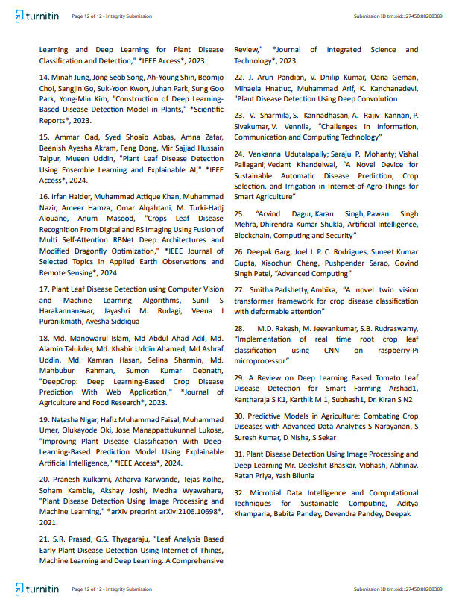

**A.5 PAPER PUBLICATION**

**Published in Conference proceeding of ISBN Number 978-93-342-0319-6**

**Conference Details:**

International Conference on Sustainable

Energy and Innovation Technology

ICSEIT 2025

Organized By

Stella Mary’s College of Engineering

Aruthenganvilai, Kallukatti Junction, Azhikal Post, Tamil Nadu, India

**Conference Date:**11th– 12th April 2025



**REFERENCES**

1. Ammar Oad, Syed Shoaib Abbas, Amna Zafar, Beenish Ayesha Akram (2024) "Plant Leaf Disease Detection Using Ensemble Learning and Explainable AI," IEEE Access.
2. Arshad, Kantharaja S. K., Karthik M., Subhash, Dr. Kiran S. N. (2023) "A Review on Deep Learning Based Tomato Leaf Disease Detection for Smart Farming."
3. Balafas, V., Karantoumanis, E., Louta, M., and Ploskas, N. (2023) "Machine Learning and Deep Learning for Plant Disease Classification and Detection," IEEE Access.
4. Bandara, P., Weerasooriya, T., and Ruchirawya, T. H. (2020) "Integrated Models for Crop Recommendation," International Journal of Computer Applications.
5. Bhaskar, D., Vibhash, Abhinav, Priya, R., and Bilunia, Y. (2023) "Plant Disease Detection Using Image Processing and Deep Learning."
6. Dagur, A., Singh, K., Mehra, P. S., and Shukla, D. K. (2023) "Artificial Intelligence, Blockchain, Computing and Security."
7. Dighe, D., Joshi, H., Katkar, A., Patil, S., and Kokate, S. (2018) "Overview of Crop Suggestion Frameworks," International Research Journal of Engineering and Technology (IRJET).
8. Dong, F., Talpur, M. S. H., and Uddin, M. (2023) "Machine Learning and Deep Learning for Plant Infection Classification and Detection."
9. Gosai, D., Raval, C., Nayak, R., Jayswal, H., and Patel, A. (2021) "IoT-Enabled Framework for Soil Testing," International Journal of Scientific Research in Computer Science, Engineering and Information Technology.
10. Haider, I., Khan, M. A., Nazir, M., Hamza, A., Alqahtani, O., Alouane, M. T. H., and Masood, A. (2024) "Crops Leaf Disease Recognition from Digital and RS Imaging Using Fusion of Multi Self-Attention RBNet Deep Architectures and Modified Dragonfly Optimization," IEEE Journal of Selected Topics in Applied Earth Observations and Remote Sensing.
11. Islam, M. M., Adil, M. A. A., Talukder, M. A., Ahamed, M. K. U., Uddin, M. A., Hasan, M. K., Sharmin, S., Rahman, M. M., and Debnath, S. K. (2023) "DeepCrop: Deep Learning-Based Crop Disease Prediction With Web Application," Journal of Agriculture and Food Research.
12. Jung, M., Song, J. S., Shin, A. Y., Choi, B., Go, S., Kwon, S. Y., Park, J., Park, S. G., and Kim, Y. M. (2023) "Construction of Deep Learning-Based Disease Detection Model in Plants," Scientific Reports.
13. Kulkarni, P., Karwande, A., Kolhe, T., Kamble, S., Joshi, A., and Wyawahare, M. (2021) "Plant Disease Detection Using Image Processing and Machine Learning," arXiv preprint arXiv:2106.10698.
14. Narayanan, S., Kumar, S. S., Nisha, D., and Sekar, S. (2023) "Predictive Models in Agriculture: Combating Crop Diseases with Advanced Data Analytics."
15. Nigar, N., Faisal, H. M., Umer, M., Oki, O., and Lukose, J. M. (2024) "Improving Plant Disease Classification With Deep-Learning-Based Prediction Model Using Explainable Artificial Intelligence," IEEE Access.
16. Padshetty, S., and Ambika (2024) "A Novel Twin Vision Transformer Framework for Crop Disease Classification with Deformable Attention."
17. Pandian, J. A., Kumar, V. D., Geman, O., Hnatiuc, M., Arif, M., and Kanchanadevi, K. (2023) "Plant Disease Detection Using Deep Convolution Networks."
18. Prasad, S. R., and Thyagaraju, G. S. (2023) "Leaf Analysis-Based Early Plant Disease Detection Using Internet of Things, Machine Learning and Deep Learning: A Comprehensive Review," Journal of Integrated Science and Technology.
19. Rakesh, M. D., Jeevankumar, M., and Rudraswamy, S. B. (2023) "Implementation of Real-Time Root Crop Leaf Classification Using CNN on Raspberry-Pi Microprocessor."
20. Shariff, S., and Shwetha, R. B. (2020) "Crop Recommendation Using Machine Learning Techniques," International Journal of Engineering Research & Technology (IJERT).
21. Sharmila, V., Kannadhasan, S., Kannan, A. R., Sivakumar, P., and Vennila, V. (2023) "Challenges in Information, Communication and Computing Technology."
22. Smitha, P., and Ambika (2023) "A Novel Twin Vision Transformer Framework for Crop Disease Classification with Deformable Attention."
23. Udutalapally, V., Mohanty, S. P., Pallagani, V., and Khandelwal, V. (2023) "sCrop: An Innovative Device for Realizable Automated Infection Prediction, Crop Determination, and Irrigation in Internet-of-Agro-Things for Smart Agriculture."
24. Yang, Z., Diao, C., and Gao, F. (2023) "Towards Adaptable Within-Season Crop Mapping With Phenology Normalization and Deep Learning," IEEE Journal of Selected Topics in Applied Earth Observations and Remote Sensing.
25. Khamparia, A., Pandey, B., Pandey, D., and Deepak (2023) "Microbial Data Intelligence and Computational Techniques for Sustainable Computing."
26. Harakannanavar, S. S., Rudagi, J. M., Puranikmath, V. I., and Siddiqua, A. (2023) "Plant Leaf Disease Detection using Computer Vision and Machine Learning Algorithms."
27. Garg, D., Rodrigues, J. J. P. C., Gupta, S. K., Cheng, X., Sarao, P., and Patel, G. S. (2023) "Advanced Computing."
28. Balafas, V., Karantoumanis, E., Louta, M., and Ploskas, N. (2023) "Machine Learning and Deep Learning for Plant Disease Classification and Detection," IEEE Access.
29. Islam, M. M., Adil, M. A. A., Talukder, M. A., Ahamed, M. K. U., Uddin, M. A., Hasan, M. K., Sharmin, S., Rahman, M. M., and Debnath, S. K. (2023) "DeepCrop: Deep Learning-Based Crop Disease Prediction With Web Application," Journal of Agriculture and Food Research.
30. Udutalapally, V., Mohanty, S. P., Pallagani, V., and Khandelwal, V. (2023) "A Novel Device for Sustainable Automatic Disease Prediction, Crop Selection, and Irrigation in Internet-of-Agro-Things for Smart Agriculture."
31. Shin, K. G., and Mckay, N. D. (1984) "Open Loop Minimum Time Control of Mechanical Manipulations and Its Applications," Proc. Amer. Contr. Conf., San Diego, CA, pp. 1231-1236.